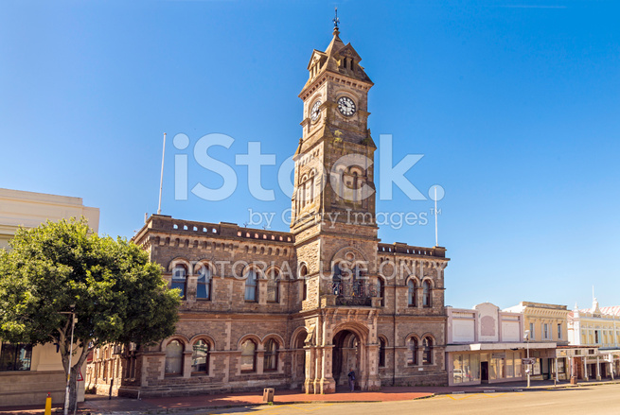

MAKANA LOCAL MUNICIPALITY

Makana Municipality strive to ensure sustainable,
affordable, equitable and quality services in a just,
friendly, secure and healthy

DRAFT ENVIRONMENTAL MANAGEMENT PLAN

INTRODUCTION 4
OUTLINE OF PROCESS AND METHODOLOGY 6
ENVIRONMENTAL OVERVIEW 10
Biophysical 10
Climate 10
Vegetation 14
Conservation Areas within Makana Local Municipality 16
Water Resources 17
Makana Municipality’s water resources include rivers, dams and groundwater, with limited evidence of wetlands. The MLM faces challenges in ensuring a reliable and safe water supply, including water shortages and water quality issues. 17
Air Quality 18
Social Environment 18
Base Population 18
Education Levels 22
Health 22
Heritage resources 22
Economic Environment 22
Economic Sectors 22
Environmental Management Issues, Opportunities and Constraints 23
Environmental Challenges 33
Prioritisation of Issues 33
CONCLUSIONS 40

(IV) ACRONYMS
CBD | – | Central Business District
MLM | – | Makana Local Municipality
DFFE | – | Department of Forestry, Fisheries and the Environmental
DEDEAT | – | Department of Economic Development, Environmental Affairs and
 |  | Tourism, Eastern Cape
DM | – | District Municipality
DWS | – | Department of Water and Sanitation
EIA | – | Environmental Impact Assessment
EMP | – | Environmental Management Plan
GDP | – | Gross Domestic Product
IDP | – | Integrated Development Plan
IEM | – | Integrated Environmental Management
IEMP | – | Integrated Environmental Management Plan
IWMP | – | Integrated Waste Management Plan
KPI's | – | Key Performance Indicators
LED | – | Local Economic Development
LM | – | Local Municipality
MAP | – | Mean Annual Precipitation
EMP | – | Environmental Management Plan
MIG | – | Municipal Infrastructure Grant
NEMA | – | National Environmental Management Act
PSC | – | Project Steering Committee
SDF | – | Spatial Development Framework
WWTW | – | Wastewater Treatment Works

INTRODUCTION
Makana Local Municipality (herein referred to as MLM) is developing an Environmental Management Plan (EMP) in accordance with the applicable legislation. The National Environmental Management Act of 1998 Makes provision for all local authorities to develop and implement a strategic environmental Management framework, often colloquially referred to as an EMP (Environmental Management Plan). The Makana LM is developing this plan in consultation with the relevant stakeholders, and it should be in line with strategic plans and ensure seamless incorporation into the Integrated Development Plan (IDP).
Makana Local Municipality is a category B municipality halfway between East London and Port Elizabeth that forms part of the Seven Local Municipalities of the Sarah Baartman (formerly Cacadu) District Municipality, in the Eastern Cape Province. Makana’s area is bordered in the north-east by Amathole District, in the Municipality with the cities of Port Elizabeth 120km to the west and East London 180km east, north-west by blue Crane Route Local Municipality, in the South by Ndlame Local Municipality and in the south-west by the Sundays River Valley Local Municipality. In 20211 the Municipality was delimited into 14 wards. Towns and Villages of Makana Municipality are as follows: Makhanda, Alicedale, Salem, Riebeeck east, Seven Fountains, Fort Brown, Sidbury, Manley Flats and Carlisle Bridge.
Area:
- Total 4,376 km2(1.690 SQ mi)
Population (2022)
- Total 97,815
- Density 22/km2(58/sq mi)

Main Economic Sectors: community services (45.9%), finance (23.7%), trade (14.4%) and mining (0.02%)
The purpose of the Plan or framework is to provide the local Municipality with a comprehensive picture of the status of the environment, and give strategic direction and structure for addressing problems, and identify opportunities concerning environmental matters, especially related to resource management.
THE EMP will provide a strategic tool for promoting sustainable development both throughout the municipality and for specific development and economic programs. In this context, EMP IS THE FOUNDATION FOR RESPONSIBLE DECISION MAKING AND MANAGEMENT OF ECOLOGICAL AND CULTURAL RESOURSES.
LEGISLATIVE FRAMEWORK
It must be considered that the national policies and legislation governing both municipal level services and responsibilities, as well as the use and management of natural resources such as water etc, which sustain many of these services, are well developed and comprehensive, and onus for compliance lies with local authorities and the communities in their jurisdiction.
Waste management is also a key basic service and is well recognised or institutionalised within the Local Municipality in such a way that IWMP is being reviewed and is at an advanced stage.

Introduction, Purpose and Objectives
The objectives of the Municipality EMP/Frame should include:
- Ensuring that there is sufficient allocation of resources on the municipality budget so that the key actions that have been identified by the EMP are implemented and the necessary monitoring, evaluation is implemented with no interruptions in order to achieve sustainability.
- Ensuring compliance with the national regulatory framework and following international guidelines especially treaties and protocols that South Africa is a signatory of.
- Having in place a verification mechanism for implementation of agreed actions, and an environmental performance management system.
- Providing feedback for continual improvement in environmental performance.
For the above objectives to be achieved, the scope of the EMP will include the following
- Definition of the environmental management objectives to be realised in the short, medium and long-term to enhance benefits and minimise adverse environmental impacts.
- Clarification of institutional structures, roles communication and reporting processes required as part of the implementation of the EMP.
- Clear delegation of framework, including how they will be achieved, by whom, by when, with what resources, with what monitoring/verification, and to what target or performance
- Mechanisms to address changes in the project/programme implementation, emergencies or unexpected events, and the associated approval processes.

OUTLINE OF PROCESS AND METHODOLOGY
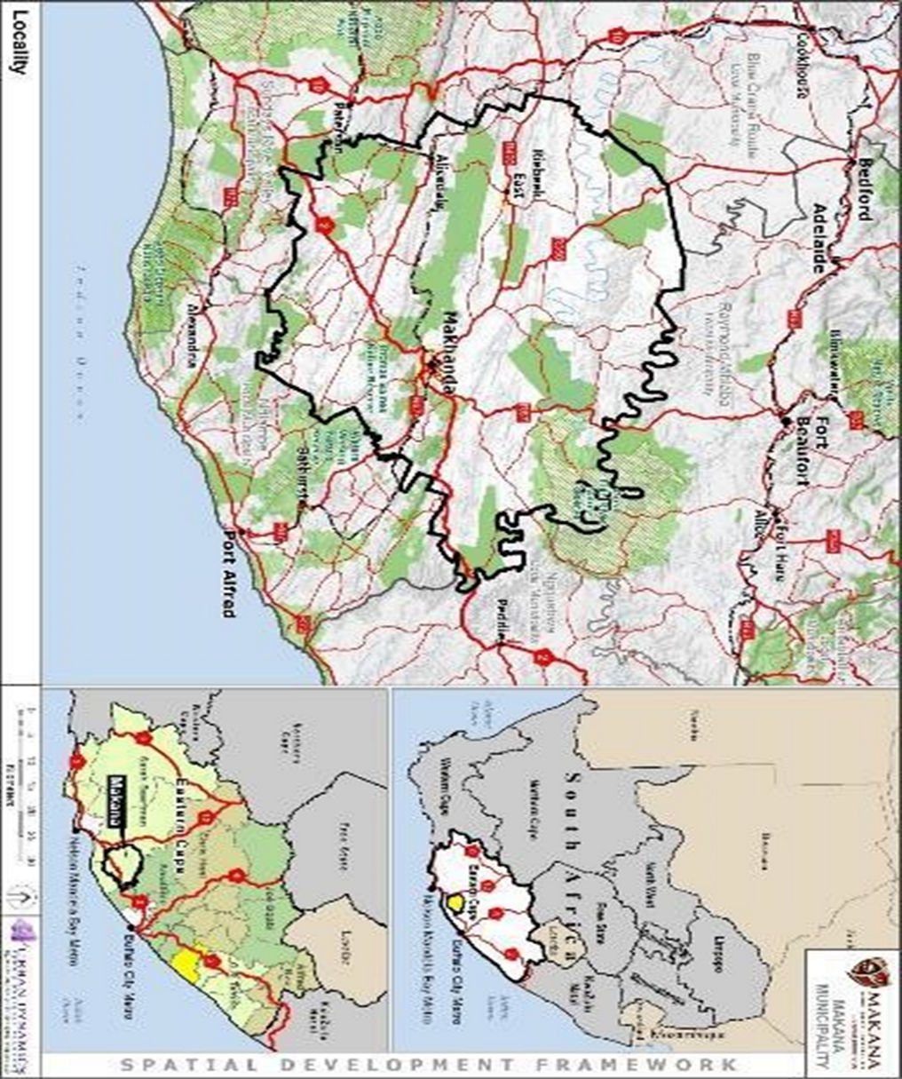
Fig 1: Makana geographic map: Map 1: Makana Municipality

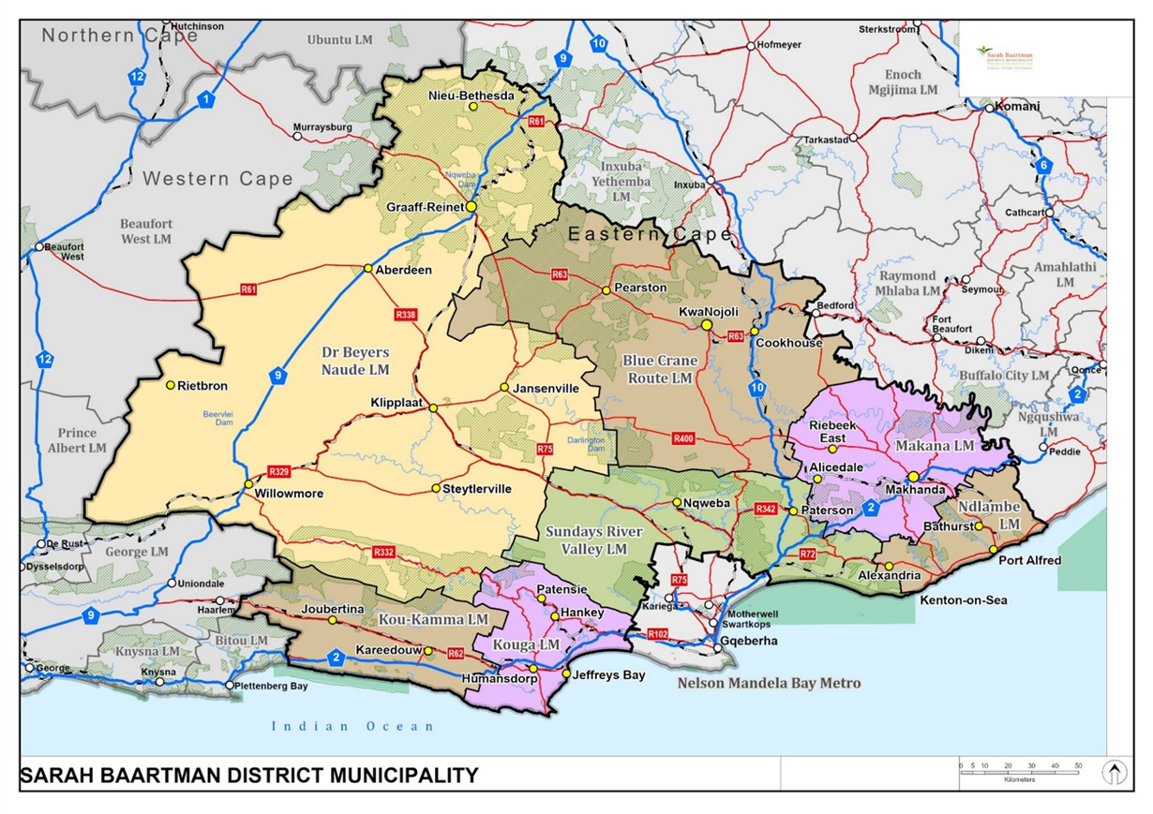
Figure 2.: The Orientation of Sarah Baartman District Municipality

ENVIRONMENTAL OVERVIEW

Biophysical

Climate
The Southern portion of the municipality has the highest rainfall. The majority of the municipality is classified as semi-arid. Makana lies in a subtropical climatic zone, meaning that the area is characterized by warm summers and cool winters and fairly evenly distributed rainfall throughout the year.
The Makhanda area experiences moderate weather conditions. Rain falls throughout the year with mean precipitation averaging 680mm. Summer temperatures (January) vary from an average maximum of 26’C to a minimum of 15’C. In winter (July) temperatures vary from an average maximum of 18’C to an average minimum of 4’C. The prevailing wind direction is from the west and southwest.

Eastern Cape Climate Change Response Strategy (DEDEAT, 2011).
Climate Change Corridor in Makana LM

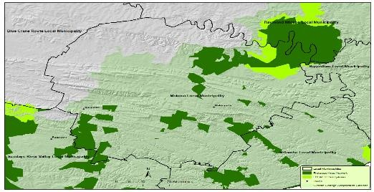
In Alicedale, rainfall is approximately 555mm per year. Temperatures in Alicedale range from 40’C to 15’C in summer and 18’C to -8’C in the winter months. Rainfall in Riebeeck East area is approximately 865mm per year, with identical average winter and summer temperatures to those experienced Makhanda.

Climate Change:
Climate change is defined as a change of climate which is attributed directly or indirectly to human activity that alters the composition of the global atmosphere, and which is in addition to natural climate variability over comparable time periods. (United Nations Framework Convention on Climate Change)
The manifestation of climate change in the Eastern Cape is expected to be:
High temperature increases towards the North -West Interior with lowest increases along the coast.
A drying trend towards the South and South -West.
Increased precipitation more likely towards the east of the province. Sea level rise scenario’s ranging from 2m to 6,5m depending on exposure. Risk assessment, adaptation and mitigation measures addressed in SBDM

Geology and Soil
From a municipal wide perspective there are no unfavourable geotechnical conditions that will prevent development or require specific safety considerations. The necessary on-site investigations should be undertaken to ensure that the site-specific circumstances are suitable for the intended development.

Topography
The eastern part of the municipality can be classified as lowlands, with contours generally lying below 300m above sea level. The western part of the locality in which Alicedale is situated can be classified as being of a moderate elevation, lying between 300m and 600m above sea level. The central part of the municipality that contains Makhanda and Riebeek East has the highest elevation of between 600m and 900m above sea level. Makhanda is situated in a valley that cuts into a plateau.
The highest point on the plateau is 770m above sea level and the lowest point in the valley is 490m above sea level. Alicedale is located about 360m above sea level in a flood plain created by the confluence of the Bushman’s river and the New Year’s river. Riebeek East is located 630m above sea level.

Topography and slope
Most of the land in Makana has a slope of either between 3-8º or between 8-20 º

Hydrology
The major water related driver in the municipal area is the Orange-Fish-Sundays Water Supply system which ensures continuous sustainable water supply for economic activity and is essential for community’s well-being and socio-economic prosperity in the area. The whole municipality is classified as a primary catchment area, with a mean quaternary runoff of between 12m³ and 40m³.
Surface water is largely provided by dams and reservoirs that are linked to perennial and nonperennial rivers. Ground water is provided by boreholes and springs that are evenly distributed throughout the municipality.
In terms of water sources in the towns it is found that:
Makhanda’s water is from local dams and sources transferred from the Orange River.
There is adequate supply to cater for the 8.6M/m³ but there is also a need for more groundwater development.
Riebeeck East’s water is sourced from local boreholes. It also has adequate supplies of water to cater for the 0.0285 M/m³ that it uses. A planned water scheme for Riebeeck East is an increase in storage capacity in the form of tanks and a reservoir.
Alicedale’s water is sourced from a local New Year dam.
With regards to the quality of water resources in the area, the State of Sarah Baartman District
Environment report of 2005 states that water quality is ‘good, or even natural (e.g. the New Year’s
Dam and Bushman’s River sites) even though it is naturally saline and not suitable for certain uses

Land and Soil Types
Land capacity is determined by the collective effects of soil, topography, hydrology and climate features. It indicates the most intensive long-term and sustainable use of land for rain-fed agriculture and at the same time highlights the permanent limitations associated with different land use classes.
Table below shows the classifications with which land is classified. It also shows different land usages that go in line with the different levels of land capability. This shows the nature of agricultural activity that can be feasibly undertaken throughout the municipality.

Vegetation
The Makana Local Municipality has diverse and unique vegetation, comprising ten vegetation types, representing all the major southern African biomes. It is this diversity which makes it essential that the efforts to conserve and manage this natural resource for the benefit of all the people of Makana be coordinated within a single authority. The district contains 136 red data book (higher plant) taxa and is an important centre of endemism in southern Africa(2548 native plant taxa). There are 27 endemics of which 17 are vulnerable, 5 are endangered and 5 are critical.
The biodiversity of the thicket within Makana is threatened by four major driving variables, namely overgrazing by domestic livestock, development of new lands for arable crop production, collection of native species for medical purposes and encroachment of invasive alien plants.
The vegetation of Makana is internationally unique and comprises ten different vegetation types. These types have recently been re-defined following the work of the Vegetation Map Project of the National Botanical Institute (Anonymous 2004), which developed a new vegetation map and associated descriptions for the whole South Africa. Makana contains vegetation representative of five different biomes, namely the Thicket, Nama-Karoo, Grasslands, Forest and Fynbos. The Albany Thicket, comprising Great Fish Thicket, Great Fish Noorsveld, Kowie Thicket, Eastern Cape Thornveld and Albany Broken Veld, is the most vegetation unit in Makana. The grassland (Bedford Dry Grassland), fynbos (Suurberg Quartzite Fynbos, Suurberg Shale Fynbos), forest (Southern Mistbelt Forest) and Nama-karoo (Southern Karoo Riviere) are also represented within Makana. The description of the biomes is as follows:
The Albany Thicket
The Albany Thicket is a unique, subtropical biome in South Africa, characterised by dense, spiny shrubland and succulent vegetation. it is a dense woodland region cantered around Grahamstown and fish River area in South Africa’s Eastern Cape. It’s known for its high plant species diversity, including numerous endemic species, and is part of the large Cape Floristic Region. The biome is characterised by a dense, often impenetrable, vegetation of evergreen, sclerophyllous, or succulent trees, shrubs, and vines, many with stem spines.

Nama-Karoo
The Nama-Karoo biome, a semi-arid region in South Africa, extends into the Eastern Cape and includes areas near Grahamstown. While not the dominant biome in Grahamstown, which is part of the Albany Centre of endemism where multiple biomes converge, Nama-Karoo vegetation types, like the lower karoo bioregion are found in the region. It is characterized by its semi-arid climate, with summer rainfall and a dry, hot season. Its vegetation consists mainly of dwarf shrubs, grasses, and other drought-tolerant plants.

Grassland
The grasslands biome is a significant feature of the area. The grasslands are characterised by a diverse range of plant life, including grasses and forbs(wildflowers), and are home to a variety of bird species.
Forestry
In MLM, the forestry biome, specifically the Southern Mistbelt Forest, is represented by the Baviaans Valley Thicket and other forest patches. This forest patch is part of the broader Afromontane Forest biome, which also includes grasslands, fynbos, and thicket vegetation.
Fynbos
The Fynbos biome is a unique Mediterranean-type shrubland in South Africa, characterised by low nutrient soils, a winter rainfall climate, and a high diversity of plants species, particularly restios and heathers. It’s known for its sclerophyllous vegetation and high levels of endemism with many species adapted to fire. The MLM in the Eastern Cape of South Africa does indeed contain vegetation representative of the fynbos biome.

Alien Plant Management

This intervention has two primary aims which are as follows:
The conversion of certain alien plant infestations (which are a liability) into an economic opportunity (charcoal, biofuel, pols, firewood, etc), and in so doing provide an economic vehicle for SMMEs/ local micro enterprises to generate income through value adding activities. This is an ambitious but possible intervention, requiring excellent technical and management skills, and well-structured partnerships between role players, including the private sector and relevant stakeholders. Various Case studies will be explored. The MLM has been funded by DEDEAT to eradicate Invasive species for the period of 8 months, the project will commence in 2025/26 financial year.
The control of existing alien tree infestations where they do not present an economic opportunity as per point above.

Waste management

MLM is in the process of reviewing its IWMP and forging partnership with various organisation within waste sector. The IWMP provides detailed outline in terms of how the waste management will be managed by MLM.

Conservation Areas within Makana Local Municipality

Protected Area
The Eastern Cape Parks and Tourism Agency (ECPTA) is the management authority as per the National Environmental Management: Protected Areas Act (No 57 of 2003) of various provincial protected areas.

Protected areas under the management of the ECPTA within the Makana Local Municipality are the Beggars Bush Nature Reserve, Thomas Baines Nature Reserve and Great Fish River Nature Reserve (see figure underneath). Protected Area Management Plans have been developed for all these protected areas by ECPTA.

Thomas Baines Nature Reserve Complex
Thomas Baines Nature Reserve Complex is a name coined to refer to a series of nature reserves situated within the Makana and Ndlambe Local Municipalities. The Reserve complex consists of Kaap River, Thomas Baines, Beggars Bush and Cycad Nature Reserves. Beggars Bush and Thomas Baines Nature Reserves are located within the Makana Local Municipality, whereas Kaap River and Cycad Nature Reserves are located within Ndlambe Local Municipality.

Thomas Baines Nature Reserve was originally established as a municipal nature reserve in 1961 and was declared a Provincial Nature Reserve in 1980 in terms of the Cape Nature Conservation
Ordinance No 19 of 1974. Beggar’s Bush State Forests were proclaimed as State Forest in 1929 respectively and are governed by the National Forests Act. Thomas Baines Nature Reserve (TBNR) is situated in the south-eastern section of the Eastern Cape approximately 13km south-west of Grahamstown.

TBNR is about 1000 hectares and comprises several farms bordering and incorporating Howison’s
Poort Reservoir and Settler’s Dam. These are both important water supplies for Makhanda.
Beggars Bush is located approximately 30km south-east of Grahamstown and 65km from TBNR
Four biomes extend across the reserve complex namely: Albany Thicket, Fynbos, Forest and Savanna biome (Mucina and Rutherford, 2006).

Water Resources

Makana Municipality’s water resources include rivers, dams and groundwater, with limited evidence of wetlands. The MLM faces challenges in ensuring a reliable and safe water supply, including water shortages and water quality issues.

Quaternary Catchments
The catchment areas within the Makana Municipality are primarily focused on water management and include the Grahamstown east area and rural areas, as well as parts of Alicedale. The municipality also manages water resources through Water User Association and Catchment forums.

Air Quality
Air quality in Makhanda is generally considered to be acceptable. The major sources of air pollution include Landfill sites, emissions from vehicles especially older diesel models, indoor fires and cool for cooking and heating, a brickmaking facility and landfill sites.
There are 3 landfill sites and most of them are licensed. These sites are however associated with uncontrolled burning and landfill gas emissions and pose additional challenges in terms of managing air quality and addressing climate change. In addition, a dumpsite of discarded wood waste results in emissions from burning.
Small-scale brick making presents a unique challenge in Makanda as well as other municipalities in the Eastern Cape using coal-fired clamp kilns.
Mining and quarries are a medium priority with a large quarry existing in a sparsely

Social Environment

Base Population

2.1.1.1 Introduction
The demographic chapter provides an overview of the key demographic indicators that will inform municipal planning and budgeting. This chapter investigates the estimated population size and density thereof, the distribution of the population within the age cohorts, dependency ratios as well as the household size and density in the municipal area.

- The municipal area is 4 375.6km²,
- Population span 22.3 people/km²
- with 29 239 households

Total Population:

The population is the number of individuals who live within a specified area. According to 2022 census, the Makana Municipality had a population size of 97 815. The total population for the Makana Municipality is estimated to increase to 102,593by 2026, growing at an average annual rate of 1.2%.
Makana Population 2022-2026

Population projections
Based on the present age-gender structure and the present fertility, mortality, and migration rates, Makana's population is projected to grow at an average annual rate of 1.2% from 97 815 in 2022 to 102 593 in 2026.
Table 1. Population projections - Makana, Sarah Baartman, eastern cape, and national total, 2022-2026 [numbers percentage]
Year | Makana |  | Sarah Baartman | Eastern Cape | National Total | Makana as % of District | Makana as % of Province | Makana as % of National
2022 | 97,815 |  | 543,000 | 7,470,000 | 61,100,000 | 17.0% | 1.23% | 0.15%
2023 | 98,988 |  | 549,000 | 7,550,000 | 61,900,000 | 17.0% | 1.23% | 0.15%
2024 | 100,175 |  | 556,000 | 7,630,000 | 62,700,000 | 16.9% | 1.24% | 0.15%
2025 | 101,377 |  | 563,000 | 7,710,000 | 63,500,000 | 17.0% | 1.24% | 0.15%
2026 | 102,593 |  | 570,000 | 7,780,000 | 64,300,000 | 17.0% | 1.24% | 0.15%
AVERAGE ANNUAL GROWTH
2022-2026 |  | 1.17% | 1.21% | 1.02% | 1.29%

The population projection of Makana Local Municipality shows an estimated average annual growth rate of 1.2% between 2022 and 2026. The average annual growth rate in the population over the projection period for Sarah Baartman District Municipality, Eastern Cape Province and South Africa is 1.2%, 1.0% and 1.3% respectively. The Eastern Cape Province is estimated to have an average growth rate of 1.0% which is very similar than that of the Makana Local Municipality. The South Africa as a whole is estimated to have an average annual growth rate of 1.3% which is very similar than that of Makana's projected growth rate.
Age Distribution | CENSUS 2011 |  |  |  |  | CENSUS 2022
Age | 0 - 4 | 5 - 14 | 15 - 34 | 35 - 59 | 60 + |  | 0 - 4 | 5 - 14 | 15 - 34 | 35 – 59 | 60 +
Sarah Baartman | 45 969 | 76 633 | 153 131 | 128 622 | 46 229 |  | 40 631 | 86 018 | 163 960 | 162 523 | 80 081
Makana | 7 180 | 12 431 | 30 702 | 22 733 | 7 344 |  | 6 761 | 14 671 | 32 727 | 31 217 | 12 431

The population table reflects a change in the structure of the population from 2011 and 2022. The differences can be explained as follows:
- In 2011, there is a significantly larger share of young working age people between 20 and 34 (32.7%), compared to what is estimated in 2022 (29.6%). This age category of young working age population will decrease over time.
- The fertility rate in 2022 is estimated to be slightly higher compared to that experienced in 2011.
- The share of children between the ages of 0 to 14 years is projected to be significant smaller (21.8%) in 2022 when compared to 2022 (23.2%).

In 2022, the female population for the 20 to 34 years age group amounts to 15.6% of the total female population while the male population group for the same age amounts to 17.2% of the total male population. In 2022, the male working age population at 15.5% still exceeds that of the female population working age population at 14.1%, although both are at a lower level compared to 2011.

 | CENSUS 2011 |  |  | CENSUS 2022 |  |  |  |  |  | GROWTH RATE
 | Total population |  |  | School attendance (5-24  years) | Sex Ratio | Total population |  |  | School attendance (5-24  years) | Sex Ratio
 | Male | Female | Total | School attendance (5-24  years) | Sex Ratio | Male | Female | Total | School attendance (5-24  years) | Sex Ratio
Sarah Baartman | 220 246 | 230 338 | 450 584 | 96 669 | 95,6 | 253 673 | 279 580 | 533 253 | 110 549 | 90,7 | 1,6
Makana | 38 175 | 42 215 | 80 390 | 18 517 | 90,4 | 45 885 | 51 930 | 97 815 | 22 021 | 88,4 | 1,9

Education Levels
72.5% of the population has complemented Grade 9 or higher. Specifically, 39.9% have complemented Matric or Higher. About 4% have no schooling, and 5656 people have a higher education level.

Health
There is a wide distribution of health service facilities in the Makana LM. The Makana LM has a total of … health facilities, which comprise of …clinics, 7 Community Health Centres (CHC) and hospitals.

Heritage resources
Heritage resources are identified and protected by the National Heritage Resources Act, 1999 (Act 25 of 1999). A significant number of documented historical and cultural resources occur within Makana LM. These consist of Makana Botanical Gardens, Rhodes University Campus, the Anglican Cathedral of St Michael and St George, and the 1820 Settlers Monument and Fort Selwyn, burial sites, areas of political significance, rock paintings and areas of past economic significance.
The Observatory Museum, Artficers’ Square also contribute to the town’s heritage. Additionally, Bully Kohl’s grave site and the St Phillips Church are worth visiting.

Economic Environment

Economic Sectors
The main economic sectors in the Makana Local Municipality include government, trade, finance and business services, manufacturing, agriculture, transport and communication, and construction. Government is the largest sector, accounting for 51.5% of the economy, followed by trade, finance and business services, and manufacturing, tourism and heritage, arts and creative industries, and agriculture and agro processing are also considered key factors in the municipality’s economy.
MLM Economic Development Strategy recognizes the five major economic sectors in terms of contribution to the area economy and Gross Domestic Product (“GDP”), as:
- Government: Government is a significant employer and a major contributor to the local economy
- Trade: Trade plays a vital role in the local economy, including retail, wholesale, and commercial activities.
- Finance and Business Services: this sector includes financial institutions, including retail, wholesale, and commercial activities.
- Manufacturing: Manufacturing activities, such as food processing and other light industries, contribute to the local economy.
- Agriculture: Agriculture, including crop farming and livestock production, is an important sector, particularly in rural areas.
Transport and Communication: Transport and communication services, such as road and rail transport, telecommunications, and postal services, are essential for the municipality’s economy.
Construction: Construction activities, such as building and infrastructure development, contribute to the local economy.
Tourism and Heritage
Arts and Creative Industries: Makana is popular tourist destination, with attractions like the National Arts Festival and its rich historical sites.
- Agriculture and Agro-processing: Makana supports agricultural development through initiatives like facilitating access to finance and land for emerging farmers and promoting rural development.
- SMME and Informal Trade

ENVIRONMENTAL ANALYSIS

Environmental Management Issues, Opportunities and Constraints
Environmental issues, opportunities and constraints can be defined as follows:
ENVIRONMENTAL ISSUE: A conflict, situation or state where the natural environment has been, or will be, compromised as a result of some pressure or impact.
ENVIRONMENTAL OPPORTUNITY: The natural environment has particular attributes or capacities which present an opportunity for development or resolution of certain issues.
ENVIRONMENTAL CONSTRAINT: The natural environment has particular attributes or a capacity limitation which presents a constraint for development or for remedying an existing issue.

The following key environmental issues, opportunities and constraints have been identified for the Makana LM:

Table 2: Environmental issues, opportunities and constraints identified in Makana LM
 | Environmental Issues | Environmental Opportunities | Environmental Constraints
Environmental governance | - The Environmental bylaws are outdated  - Insufficient of environmental policy.  - Reliance on external resources (DEDEAT, DFFE and other donors) for the execution of Environmental programmes.  The need for environmental impact assessment as part of planning for all proposed developments which may have potential to change the current environment. The need to consider environmental impact assessment as part of planning for all proposed developments which may have potential to change the current environment. | Establishment of environmental policy and management capacity within the municipality.  support from other spheres of government to help police compliance with potentially polluting activities in the municipal area.  Job opportunities to dedicate personnel to monitor environmental compliance within LM. | Limited financial resources.
Core Conservation Areas | - Loss of biodiversity conservation areas to agriculture and development (formal and informal).  - Fragmentation of certain biomes due to poor veld management. | - Thomas Baines Nature Reserve Complex and other natural areas present good potential for  nature based tourism opportunities.  - The local conservation areas have the potential to have an increased contribution into the local GDP. | • Sensitive landscape with a low carrying game / stock capacity that does not recover easily from disturbance / damage.
Natural Buffer Areas | - Loss of pristine natural areas to agriculture and development.  - Poor management of grazing land in rural areas by emerging farmers. | • Employment opportunities through alien invasive plant clearing, tree/shrub planting, etc. | - Sensitive landscape with a low carrying game / stock capacity that does not recover easily from disturbance / damage.  - Natural areas of conservation importance, such biomes pose a

 | Environmental Issues | Environmental Opportunities | Environmental Constraints
 |  |  | constraint on certain types of development that may be envisaged.
Agricultural areas
Urban Agriculture | • Changes in hydrology and water quality of pans and wetlands with transformation of catchment areas to agriculture. | - Extensive coverage of natural areas presents a key opportunity for a range of economic activities associated with game farming. E.g. eMthonjeni-Fairview Spring Wetland.  - Soil erosion rehabilitation programmes may pose an opportunity for job creation.  - Local food security programmes could be established using permaculture and rainwater harvesting approaches. | - Low grazing capacity limits the quantity of livestock or game.  - Regulations to manage land use management are not enforced.  - Resource limitations such as water availability constrain agricultural  development and local food security options, particularly for emerging farmers.  - Sensitive landscape with a low carrying game / stock capacity that does not recover easily from disturbance / damage.
Commonage | There is a problem of overgrazing by roaming livestock at the municipal commonages.  Commonage is placed under pressure due to rapid urban growth and presence of informal settlement and incorrect environmental management practices. | The Municipality is currently managing the commonages as a strategy to alleviate poverty. Local emerging | Regulations to manage land degradation of commonage are not enforced.

 | Environmental Issues | Environmental Opportunities | Environmental Constraints
 |  | More farmers could be given the commonage to practice farming.
Region agriculture | - Soil degradation, including soil leaching, compaction, trampling and erosion constantly reduces the agricultural potential of the district. These weaknesses are caused by unsustainable agricultural practices  (such as over utilization of soils)  - Land with high agricultural potential is under threat from unsustainable land uses, poor agricultural practices and land reform.  - Capacity to identify requirements and obligations in terms of NEMA, NWA and CARA. | - Makana LM has some  of the country’s richest land for agriculture.  - Agriculture constitutes one of the key drivers of local economy.  - The municipal area hosts both successful commercial farmers as well as emerging farmers.  - Farming activities in the Makana LM make the most important contribution to employment.  - Farming in the Karoo region also contributes to local and district tourism.  - The favourable climatic conditions of the area make urban agriculture and the practice of permaculture a good opportunity to uplift poor households and to increase food security. This should be actively promoted.  - Agriculture has a potential to give rise to other activities such as weaving and products from wool, hides, etc. | - Veld fires and drought  - Farming operations are mostly restricted to dry land farming, livestock and game farming.

 | Environmental Issues | Environmental Opportunities | Environmental Constraints
Urban Related Areas
Land use  management schemes | - Erosion caused by poor land management practices (overgrazing, land cover removal, veld fires, etc.).  - Encroachment by alien invasive vegetation. | • There is an opportunity for economic growth and development since there is land available for land uses such as agriculture, business, industry, residential, institutional and other land uses. | • Adequate financial resources for skills absorption, proper land use management and  land use implementation.
Residential | - The use backet system, badly located facilities and poorly designed sanitation facilities have a negative impact on soil and water resources.  - Leakages and pipeline burst from waterborne sanitation systems poses pollution issues to the environment.  - Poor solid waste management have a negative impact on the environment and human health.  - Illegal water use through unauthorised abstraction, connections and non-compliance with DWS guidelines on water use. This leads to inability to understand and manage the reserve in subcatchments. | - Extensive coverage of natural areas presents a key opportunity for a range of economic activities to support the residential area development.  - Maintenance, greening, waste collection and sorting for recycling, and land rehabilitation programmes may pose an opportunity for job creation and environmental awareness amongst the local residents.  - Local food security programmes could be established using permaculture and rainwater harvesting approaches. | Technical, managerial and human resource skills shortages, combined with inadequately skilled contractors and operators, and lack of monitoring and accountability.

 | Environmental Issues | Environmental Opportunities | Environmental Constraints
CBD and development nodes | - Overdependence on government for income generation.  - Slope areas which are not suitable for urban development. | • Potential urban renewal for Makhanda. | Resource limitations such as water availability may constrain development, urban greening and food security programmes.
Urban open spaces | - Illegal / informal settlement which are poorly located and difficult to service.  - Poor urban landscape quality in certain locations – incompatible land uses, poorly maintained roads, and limited or no greenery / landscaping.  - Illegal dumping  - Encroachment by alien invasive vegetation. | Urban greening could be strengthened in such a manner as to create green jobs, sustainable livelihoods, while improving local urban landscape quality.  Some of the open spaces could be converted into public leisure parks, food gardens, etc.  Maintenance of open spaces may create employment opportunities for the local people. | - Capacity to enforce zoning and building regulations.  - Local communities may resist changes in land use management of  commonage areas and reduction in stocking rates.
Cemeteries | - Potential contamination of groundwater.  - Unfenced cemeteries.  - Cemeteries that are reaching capacity  - Improper maintenance of cemeteries | Employment opportunities and revenue collection.  Job opportunities for care takers, general workers and contract workers for the maintenance of cemeteries and the running of day-to-day activities.  New cemetery establishment funded by Municipal Infrastructure Grant. | Availability of suitable land for development of cemeteries
Industrial Areas
Industries | Industries put pressure on the already limited water resources of the area.  Air Quality issues and a lack of monitoring of air quality of these industries. | Access to primary raw materials such as wool, leather and milk from local agriculture.  Industries could contribute to employment opportunities for the local people and contribute to the local economic growth. | Scarce water, especially in the Makhanda area during certain seasons, limits industrial development.

 | Environmental Issues | Environmental Opportunities | Environmental Constraints
 | Waste by-products could contribute to pollution problems.
Surface infrastructure
Landfill sites | Illegal dumping and burning of solid waste.  Illegal dump sites pose a human health and environmental pollution risk.  Landfill sites poorly managed and not compliant with license conditions e.g. lack of access control, lack of implementation plan for prevention against pollution. | Establishment of MRF, access control and tariff system at landfill sites may generate additional revenue for the Makana LM to assist in proper landfill site management.  Municipal supported recycling / waste buyback programmes would potentially be established as a local sustainable livelihoods initiative. | - Introduction of access control and tariff system at landfill sites may result in increased illegal dumping.  - Certain areas e.g. farms are unlikely to be included in formal system for refuse collection due to transport costs.

 | Environmental Issues | Environmental Opportunities | Environmental Constraints
 | Burning of refuse – local air quality impacts and fire risks.
Bulk Service Provision: Water purification | - Some households receive water which is below the RDP standards.  - Aging water treatment infrastructure may create water interruption problems during maintenance. | Improved service delivery would speed up development and enable economic investment in the area.  Improved infrastructure and support services will generate high return rates and boost economic activity, create labour-intensive jobs and raise skill levels in the area. | Financial resources to purify and continually test water boreholes and to ensure that the purified water is  continually tested to comply with SANS and DWS water quality standards.
Bulk Service Provision: Wastewater treatment works | Effluent discharged from WWTW  contributes to pollution of the watercourses, especially Kowie River by Mkhanda WWTW.  Frequent breakage of pumps poses a serious challenge to the natural environment in that they result in spills and on-going pollution of receiving environment, and human health risks. | - Employment opportunities for the upgrade and continual maintenance of the WWTW. | Financial resources
Infrastructure Services: Water network | . | .

 | Environmental Issues | Environmental Opportunities | Environmental Constraints
 | - Water quality issues associated with groundwater supplies.  - Lack of awareness about water conservation and no water demand management programme in place.  - Free basic water for indigent households – discourages water conservation. | - Water conservation awareness and demand management programme could reduce water demand, risks and pressure on wastewater infrastructure.  - Creation of employment opportunities through  implementation of municipal wide Pipe Replacement or Leak Repair Project. | quality and available quantity.  - Limited financial resources for water augmentation and conservation measures.  - Limited local water supply capacity from rivers and boreholes due to low rainfall and high evaporation in the area.
Infrastructure Services: Sewer network | - Frequent bursting of pipelines poses a serious challenge to the natural environment.  - The areas where waterborne sewer network is not yet installed are a threat to water quality. | • Creation of employment opportunities through implementation of municipal wide Pipe Replacement or Leak Repair Project. | • The Makana LM depends on other donors for finances to manage the local bulk sewer network.
Infrastructure  Services: Electricity network | - The Makana LM buys  electricity from Eskom and sells to residents at increased costs. This is a disadvantage to the low-income earners.  - Electricity supply does not meet the demand of the increasing households. Without electricity, households use other energy sources such as coal, paraffin, wood, etc. which trigger problems | - Opportunities for ‘clean energy’ from wind and solar should be rolled out to augment Eskom electricity. This will play a crucial role in climate change  - Investigate heating and cooking options for low income households e.g. solar cookers, wonder bags, etc. | Limited funds for capital project for alternative electricity.
 | Environmental Issues | Environmental Opportunities | Environmental Constraints
 | such as air pollution and health issues.

Environmental Challenges
The Makana Municipality is faced with several environmental challenges ranging from alien plants, water quality and quantity. waste management, and habitant degradation. Poor water ecosystem health due to factors like informal settlements and industrial discharges is a major concern. Furthermore, illegal dumping sites are also a big challenge especially in townships. Inappropriate disposal of hazardous waste is also another contributing factor.
The greatest challenge facing government and local government in particular, is how to minimise harmful environmental practises that contribute to global warming and ultimately climate change. A workshop was recently held in the Province to promote awareness of the problems created by global warming and climate change. MLM does not have EMP, the development of this document will assist a lot in terms of managing the natural resources of Makana LM. This plan will highlight areas of the environment which should be conserved and protected, animal and vegetation species. Environmental related issues are taken care by Public Safety and Community Services Directorate which should focus on the following.
- The MLM appoint dedicated environmental staff including Environmental Management Inspectors( EMIs)
- The MLM should develop an integrated environmental management system
- The MLM should implement pollution control measures such as air quality monitoring
- The MLM to undertake environmental impact assessments (EIA’s) for all its current and future projects and should be assisted by the relevant authorities.

Prioritisation of Issues
The following table presents a long list of environmental management issues. In order to ensure a focused response by the MLM to these, prioritization is required. For the purposes of the IEMP, the following criteria have been used in the prioritization approach:

- Magnitude Refers primarily to the spatial extent of the issue and / or its
associated impacts. A score of 1 is given for restricted spatial extent; 2 = limited extent; 3 = extensive.
- Severity Refers to the intensity of harm that the impacts that are associated with the issue cause to the natural, social or economic environments. Score of 1 = limited intensity of effects; 2 = moderate intensity of effects; 3 = high intensity of effects.
- Risk Related to whether the issue represents a risk to human life or health, ecosystems of species, a financial or economic risk. Score of 1 = no risk; 2 = moderate risk; 3 = high risk.
- Image Refers to whether the issue has negative implications for the reputation or image of MLM. This is important in the context of the municipality as an economic investment, lifestyle and tourism destination, and in terms of the municipal administration’s bankability in terms of funding for municipal infrastructure. Score of 1 = no effect on image; 2 = moderate negative effect; 3 = significant negative effect.
- Temporal Refers to whether the impacts associated with the issue take place in the short, medium or long term. Score of 1 = short periods of time; 2 = intermittently; 3 = long periods of time.
- Opportunity costs Refers to whether the issue will result in opportunity costs due to a lack of investment in the area. Score of 1 = no effect; 2 = possible opportunity costs; 3 = definite opportunity costs.
Each issue is scored from 1 to 3 for each of the six criteria above. Total scores were then ranked as follows:

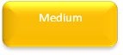

= score of 14 – 18

= score of 10 – 13

= score of 0 – 9

In all cases where there is a direct obligation for the MLM in terms of environmental legislation, these items were automatically designated as HIGH PRIORITY. Table below presents the prioritization of the issues.

Table 3: Environmental issues ranked according to priority

Local  Municipality | Category | Environmental Issues | Magnitude | Severity | Risk | Image | Temporal | Opportunity Costs | Total
MLM | Water use | There is substantial inaccessibility to water in the area mainly due to backlogs. | 3 | 3 | 2 | 3 | 3 | 3 | 17
MLM | Water quality | Sanitation infrastructure is poor in the LM. 10% of the population is without proper sanitation facilities. | 3 | 2 | 3 | 3 | 3 | 3 | 17

Municipality | Category | Environmental Issues | Magnitude | Severity | Risk | Image | Temporal | Opportunity Costs | Total
MLM | Soil | Soil erosion, including stream banks, due to poor land management and overgrazing | 3 | 3 | 2 | 2 | 3 | 2 | 15
 | Alien plants | Encroachment by alien invasive vegetation. | 3 | 3 | 2 | 3 | 3 | 2 | 17
MLM | Waste management | Poor solid waste management have a negative impact on the environment and human health. | 2 | 2 | 2 | 3 | 3 | 3 | 15
MLM | Electricity | There are large backlogs of power supply | 2 | 2 | 1 | 3 | 3 | 3 | 14
MLM | Soil | Soil erosion, including stream banks, due to poor land management and over grazing | 3 | 3 | 2 | 1 | 3 | 2 | 14
MLM | Land use | Loss of sensitive environments and biodiversity, and habitat degradation. through development in river catchment, wetlands and areas prone to erosion | 3 | 2 | 2 | 2 | 3 | 2 | 14

Local  Municipality | Category | Environmental Issues | Magnitude | Severity | Risk | Image | Temporal | Opportunity Costs | Total
MLM | Environmental capacity building | Lack of legal compliance. | 3 | 2 | 2 | 2 | 3 | 2 | 14
MLM | Environmental capacity building | Capacity to identify requirements and obligations in terms of NEMA, NWA and CARA. | 3 | 2 | 2 | 2 | 3 | 2 | 14

Local  Municipality | Category | Environmental Issues | Magnitude | Severity | Risk | Image | Temporal | Opportunity Costs | Total
MLM | Waste management | Illegal dumping, which results in land degradation, water pollution and could potentially result in health issues. | 2 | 2 | 2 | 3 | 2 | 2 | 13
MLM | Air quality | Burning of refuse – local air quality impacts and fire risks. | 2 | 2 | 2 | 2 | 3 | 2 | 13

CONCLUSIONS
This MLM is predominantly urban, with 90% of the population residing in the town of Makhanda. While Makana Municipality also encompasses rural areas, majority of its population lives in the urban centre of Makhanda, which is the largest town and seat of the municipality.
- A high proportion of the people living in the MLM are grant dependent rather than actively productive.
- Unemployment is high, and most households rely on social grants and remittances from family members working elsewhere.
- The majority of educated and able-bodied people leave the area and seek employment elsewhere.
- Growing populations in towns face resource shortages, aging and inadequate infrastructure and quality issues e.g. sewage into rivers due to overloaded systems.
- In an attempt to speed up service delivery and development for the communities, the environment and its capacity to sustain itself have been severely compromised.

