****





REQUIREMENTS FOR **EMBEDDED GENERATION**

Conditions and application process to become a small-scale embedded generator in the Municipality of Makana

February 2023

Contents

[i. Information on this document 5](#_Toc128033200)

[ii. Glossary & Definitions 7](#_Toc128033201)

[iii. Types of systems 9](#_Toc128033202)

[iv. Abbreviations 10](#_Toc128033203)

[1. Introduction 11](#_Toc128033204)

[1.1. Connecting larger generators to the distribution grid 11](#_Toc128033205)

[2. Indemnity, Legal Requirements & Curtailment 12](#_Toc128033206)

[2.1. Legal and Illegal Connections to the municipal electrical network 12](#_Toc128033207)

[2.2. Generation Curtailment 12](#_Toc128033208)

[2.3. Right to adapt rules & regulations 12](#_Toc128033209)

[2.4. Right to deny access 12](#_Toc128033210)

[2.5. Unsuccessful applications 13](#_Toc128033211)

[2.6. Application processing timeframes 13](#_Toc128033212)

[2.7. Recourse for the customer 13](#_Toc128033213)

[2.8. Contract with the municipality 13](#_Toc128033214)

[2.9. Transfer/change of ownership 13](#_Toc128033215)

[3. General Guidelines - Small Scale Embedded Generators 14](#_Toc128033216)

[3.1. Registration or Generation licence 14](#_Toc128033217)

[3.2. Self-consumption vs IPPs (pure generators). 14](#_Toc128033218)

[3.3. Exporting electricity 14](#_Toc128033219)

[3.4. Wheeling. 15](#_Toc128033220)

[3.5. Applicable technical standards 15](#_Toc128033221)

[3.6. Testing of Inverters. 16](#_Toc128033222)

[3.7. Islanding / Anti-Islanding installations 16](#_Toc128033223)

[3.8. Battery or other Storage. 16](#_Toc128033224)

[3.9. Hybrid inverters operating in islanded (off-grid) mode. 17](#_Toc128033225)

[3.10. Fire safety and emergency shut-off switch 17](#_Toc128033226)

[3.11. Dead Grid safety Lock 17](#_Toc128033227)

[3.12. Qualified installers. 17](#_Toc128033228)

[3.13. SSEG Sign-off on Commissioning 17](#_Toc128033229)

[3.14. Decommission of SSEG system. 18](#_Toc128033230)

[3.15. Eskom grid connection 18](#_Toc128033231)

[3.16. SSEG applications from sub-tenants, complex residents or other non-municipal customers. 18](#_Toc128033232)

[3.17. Off-grid system 18](#_Toc128033233)

[3.18. Advice for the customer 18](#_Toc128033234)

[3.18.1. Load profile management to maximise benefit to the customer 18](#_Toc128033235)

[3.18.2. Roof strength for PV installations 19](#_Toc128033236)

[3.18.3. Installer experience and accreditation 19](#_Toc128033237)

[4. Metering 20](#_Toc128033238)

[4.1. Metering installation and reverse power flow/ feed-in to the municipal electrical network 20](#_Toc128033239)

[4.2. Adaption of electrical metering installation 20](#_Toc128033240)

[4.3. Refunds of electricity already pre-purchased 20](#_Toc128033241)

[5. SSEG connection criteria 21](#_Toc128033242)

[5.1. Shared LV feeders 21](#_Toc128033243)

[• SSEG nameplate power rating shall not exceed the consumer’s NMD (or UIC – Utility Installed Capacity) 21](#_Toc128033244)

[• SSEG maximum export capacity shall not exceed 25% of the customers NMD 21](#_Toc128033245)

[• Maximum battery/storage charging current shall not exceed 25% of the NMD 21](#_Toc128033246)

[5.2. Dedicated LV feeders 22](#_Toc128033247)

[• SSEG nameplate power rating shall not exceed the consumer’s NMD (or UIC – Utility Installed Capacity) 22](#_Toc128033248)

[• SSEG maximum export capacity shall not exceed 75% of the customers NMD 22](#_Toc128033249)

[• Maximum battery/storage charging current shall not exceed 25% of the NMD 22](#_Toc128033250)

[5.3. Phase balancing 23](#_Toc128033251)

[5.4. Cumulative SSEG capacity and impact on LV and MV networks 23](#_Toc128033252)

[5.5. Grid impact studies 23](#_Toc128033253)

[6. SSEG Tariffs 24](#_Toc128033254)

[6.1. Residential SSEG Tariff 24](#_Toc128033255)

[6.2. Commercial and Industrial SSEG Tariff 24](#_Toc128033256)

[6.3. Billing Period 25](#_Toc128033257)

[6.4. Connection Costs 25](#_Toc128033258)

[6.5. Increased Costs 25](#_Toc128033259)

[6.6. Time-of-Use Tariffs 25](#_Toc128033260)

[7. Approvals required from other municipal departments 25](#_Toc128033261)

[7.1. Buildings/Planning department 25](#_Toc128033262)

[7.2. Other Approvals 25](#_Toc128033263)

[8. What payments may be due by the customer? 25](#_Toc128033264)

[9. SSEG application process 26](#_Toc128033265)

[10. Changes to existing approved systems 27](#_Toc128033266)

[11. ANNEX A: Grid Impact Study Overview 29](#_Toc128033267)

[o General grid impact studies 29](#_Toc128033268)

[o Requirements for more complex Grid Impact Studies 29](#_Toc128033269)

[o Grid Impact Study Specification Guide 30](#_Toc128033270)

[12. ANNEX B: New Owner/Account Holder Declaration 31](#_Toc128033271)

Disclaimer and Indemnity

The information contained in this document is for information purposes only and to guide stakeholders regarding the requirements and application process of the Municipality of Makana in connecting embedded generation to the municipal electricity network. The opinions expressed are in good faith and while every care has been taken in preparing this document, and the authors make no representations and give no warranties of whatever nature in respect of these documents, including but not limited to the accuracy or completeness of any information, facts and/or opinions contained therein.



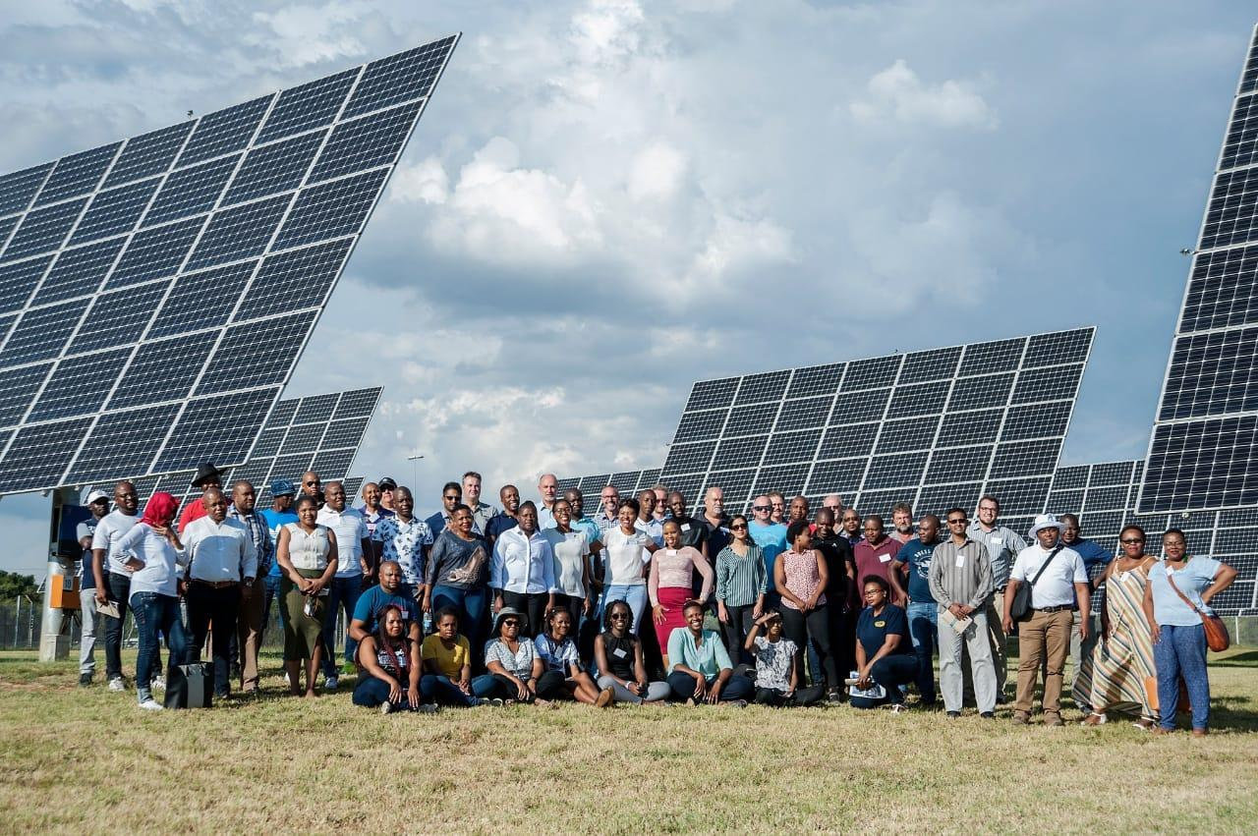

Acknowledgements

|  |  |
| --- | --- |
| C:\Users\aferry\Documents\11 SALGA general docs\Salga - Primary Logo Options - RGB1.jpg | SALGA facilitated and contributed to the development of the standard SALGA-AMEU documentation |
|  | Sustainable Energy Africa contributed to and compiled the standard SALGA-AMEU documentation |
| C:\Users\Admin\Desktop\GreenCape2\v2\Green Cape _ Primary logo _ 72dpi-01.jpg | This document was informed by the GreenCape SSEG guideline for Western Cape municipalities |
|  | The development of the document was funded by GIZ’s support programme for renewable energy in South Africa |

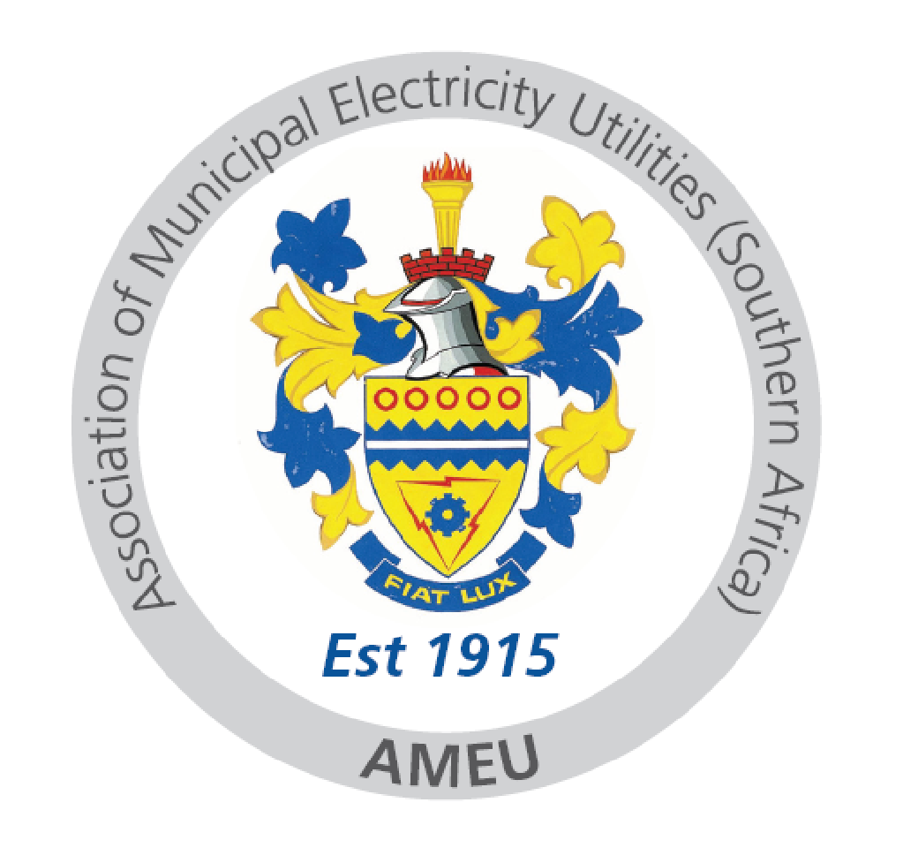

AMEU Working Group on standardised SSEG documentation:

|  |  |  |  |
| --- | --- | --- | --- |
|  |  |  | http://www.nelsonmandelabay.gov.za/Images/Logo_Colour.png |
| Johannesburg – City Power | Tshwane | eThekwini | Nelson Mandela Bay Metropolitan Municipality |
| Buffalo City Metropolitan Municipality |  |  |  |
| Buffalo City | Mangaung - Centlec | Cape Town | Ekurhuleni |

Contact details: AMEU: 011 061 5000

SALGA: 012 369 8000

# Information on this document

|  |  |
| --- | --- |
| **Purpose of the document** | This document primarily sets out the requirements and application process of the Municipality in connecting all forms of Embedded Generation (EG) to the municipal electricity network. The focus is on Small-Scale Embedded Generation (SSEG), but information is also provided for the connection of larger generators. |
| **Defining small scale embedded generation** | Small-scale embedded generation (SSEG) refers to power generation installations **less than or equal to 1MVA/1000kVA** which are typically located on residential, commercial or industrial sites, and generated power is mainly for **self-consumption**. SSEG is in contrast to large-scale generation units that generate large amounts of power, typically in the multi-Megawatt range, and are often pure generators (not for self-consumption) |
| **The need for this document** | The parallel connection of any generator to the municipal electrical network, however powered, has numerous implications for the Municipality. It therefore needs to be regulated and managed. This document serves to:   * Ensure the safety of the municipal staff, the public and the user of the SSEG installation. * Uphold the power quality of the municipal electricity network * Clarify metering and billing requirements and options   In addition, municipalities are faced with low carbon development imperatives and economic growth challenges. SSEG can play a role in both of these areas, and the document therefore also serves to:   * Promote the development of the SSEG industry by creating a conducive environment for growth. |
| **Scope** | This document covers:   * The connection SSEG installations to the municipal electrical network * Installations up to 1MVA * Installations connected to low voltage networks * Installations with self-consumption   This document does not provide detail on:   * Systems with a generation capacity above 1MVA (anyone wanting to connect a SSEG system greater than 1MVA should engage with the municipality for relevant requirements and procedures before commencing with any application). * Wheeling of electricity * The connection of SSEG to the Eskom electrical grid. * Systems connecting to MV and HV networks (although the NRS 097-1 standards covering MV and HV connections are not complete, such systems may be approved by the Municipality, but are likely to require further grid studies and should be discussed separately with the municipality) |
| **Who this document is for** | This document will assist all relevant stakeholders involved in the commissioning, installation, management and ownership of an SSEG system, with generation capacity less than or equal to 1 MVA (1000 kVA), including:   * SSEG project developers * Residential and commercial property owners * SSEG installers * Energy consultants commissioned to design SSEG systems * Municipal officials involved in SSEG generation * Registered technical personnel who are involved in SSEG commissioning |

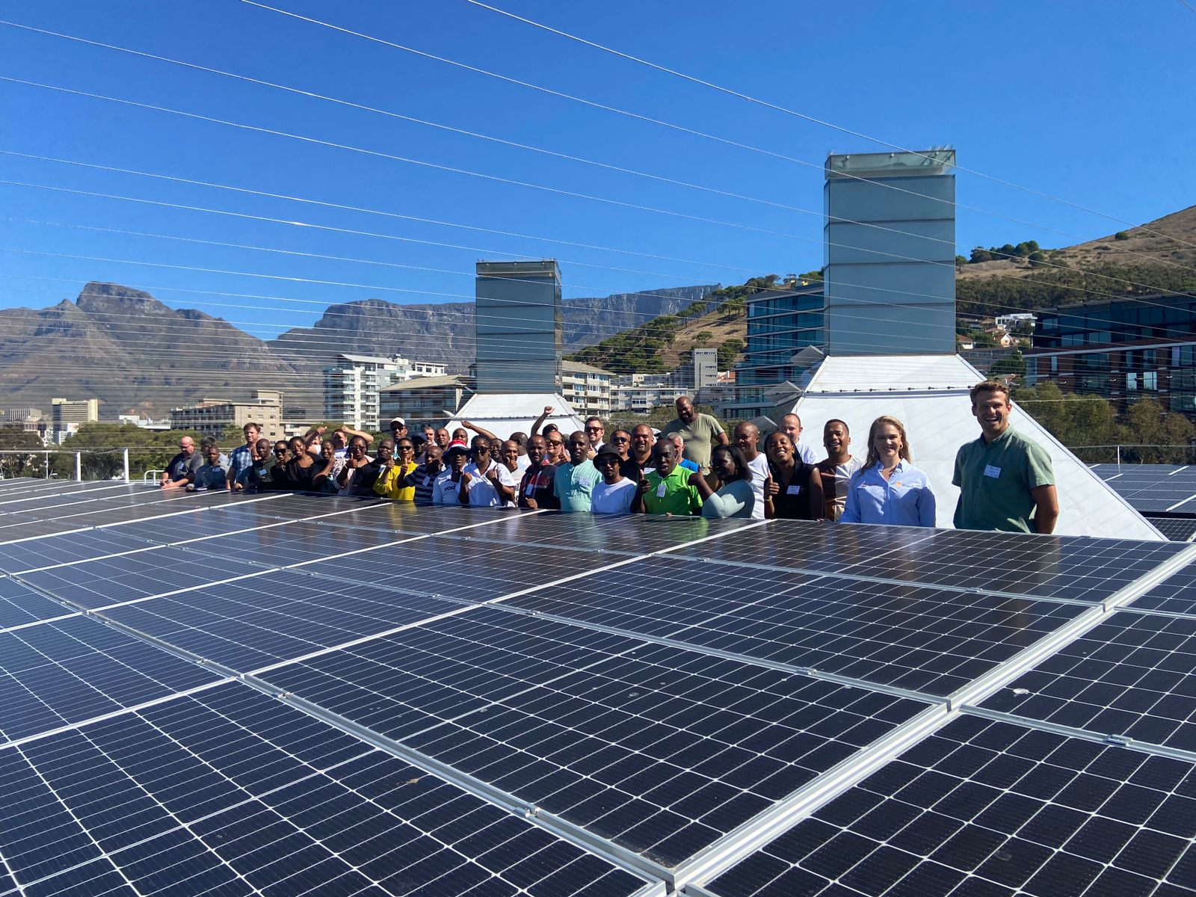

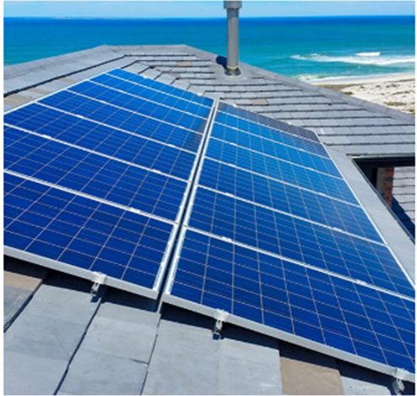

# Glossary & Definitions

|  |  |
| --- | --- |
| **Alternating current** | The flow of electrical energy that follows a sine wave and changes direction at a fixed frequency (i.e. it ‘alternates’). Most residential and commercial uses of electricity require alternating current. |
| **Direct current** | The flow of electrical energy in one constant direction. Direct current is typically converted to alternating current for practical purposes as most modern uses of electricity require alternating current. |
| **Anti-Islanding** | The ability of an SSEG installation to instantly and automatically disconnect the SSEG installation from the municipal electrical network whenever there is a power outage in the municipal electrical network, thus preventing the export of electricity to the municipal electrical network from the SSEG installation. This is done primarily to protect municipal electrical network workers who may be working on the electrical network and who may be unaware that the electrical network is still being energized by the SSEG. |
| **Bi-directional meter** | A meter that separately measures electricity flow in both directions (import and export) |
| **Customer** | In the context of this document, customers who also generate shall be referred to as “customers”, although in effect they are generators. |
| **Embedded generator** | A generator connected to the municipal distribution network. These are typically on a customer’s property and behind their meter. |
| **Generating capacity** | The maximum amount of electricity, measured in kilovolt Amperes (kVA), which can flow out of the generation equipment into the customer’s alternating current wiring system. This is therefore the maximum alternating current power flow which can be generated by the system in its current configuration. |
| **Grid-tied** | An SSEG installation that is connected to the municipal electrical network either directly or through a customer’s internal wiring is said to be “grid-tied”. The export of energy onto the municipal electrical network is possible when generation exceeds the customer’s consumption at any point in time. |
| **Hybrid grid-tied system** | **As used in this document**: A generation configuration, typically solar PV, which includes battery storage and where the system can operate in grid-tied mode as well as independently of the grid – for example during load shedding. |
| **Inverter** | A power device that converts direct current to alternating current at a voltage and frequency which enables the SSEG installation to be connected to the municipal electrical network. |
| **Isolated** | A section of a municipal electrical network which is disconnected from all other possible sources of electrical potential is said to be isolated |
| **Load profile** | The profile or curve showing the variation of the customer’s rate of electricity consumption (or demand) over time. |
| **Low-voltage** | Voltage levels up to and including 1 kV (1kV= 1000 Volts) |
| **Medium-voltage** | Voltage levels greater than 1 kV up to and including 35 kV. |
| **Pr Eng or Pr Tech Eng or Pr Techni Eng** | This refers to a professional engineer, professional technologist or professional engineering technician who is registered with the Engineering Council of South Africa (ECSA). |
| **Reverse power flow** | The flow of energy from the customer electricity installation onto the municipal electrical network (i.e. export) as a result of the instantaneous generation exceeding the instantaneous consumption at the generation site in question. |
| **SSEG Connection Contract** | The terms and conditions governing the connection of the SSEG installation to the municipal electrical network accepted by the customer |
| **Small Scale embedded generator or SSEG** | A small-scale embedded generator for the purposes of these guidelines is an embedded generator with a generation capacity of less than or equal to 1000 kVA (1MVA). |
| **Stand-alone generator/ off-grid generator** | A generator that is not in any way connected to the municipal electrical network. Export of energy onto the municipal electrical network by the generator is therefore not possible. |

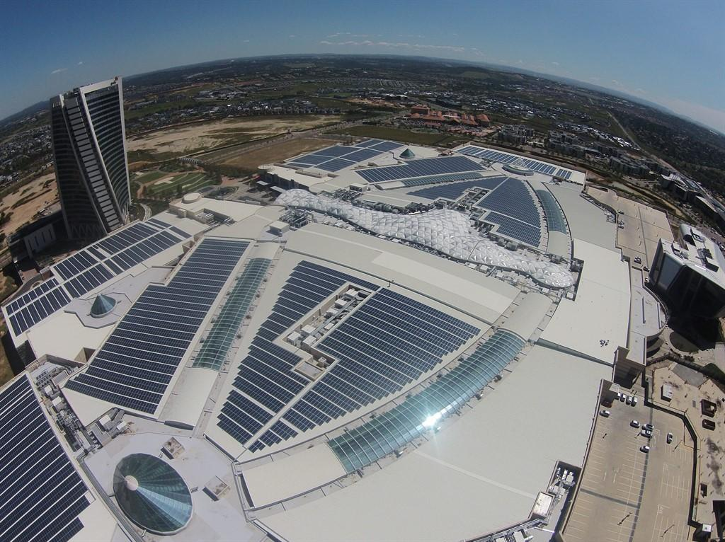

# Types of systems

|  |  |
| --- | --- |
| DESCRIPTIONS OF SYSTEM TYPES | Do they need to comply with Municipal Requirements doc? |
| **Grid Tied Solar PV Systems**  Solar PV systems that connect to and run in parallel with the grid and don’t include any form of energy storage. These systems need the grid supply to synchronize and supply power simultaneously with the utility network. When installed on the customer side of the utility meter, they are mainly installed for self-consumption to reduce the customers’ electricity bill. They cannot supply back-up power during a power failure. | These systems **must comply** with all Municipal embedded generation requirements. |
| **Off Grid or Stand-Alone solar PV systems**  Off grid solar PV systems, are systems that supply power from both solar and/or batteries through an off-grid inverter that has no electrical connection to the utility grid. These systems can be supported with a back-up generator to charge batteries and/or supply loads when there is insufficient solar PV and/or battery energy available.  NOTE: Inverters labelled as Off Grid inverters shall not be used for grid connected solar PV systems. | Because these systems cannot generate in parallel with the grid, they **do not need to comply** with Municipal embedded generation requirements. |
| **Back-up or standby (UPS) systems**  Back-up or standby uninterruptable power supply (UPS) systems stores energy in batteries through a charger and then only supplies power to the loads from these charged batteries via an inverter during a power outage. Fuel generators can also be used as back-up or stand by power supply. These systems require a suitable change over switch to select power supply between the utility and the back-up power supply, as the two supplies shall never be supplied simultaneously. | Because these systems cannot generate in parallel with the grid, they **do not need to comply** with Municipal embedded generation requirements. |
| **Hybrid Grid Tied Solar PV systems**  Grid tied/connected hybrid systems are those that combine two or more energy sources like solar PV, batteries, diesel generator or wind, which are connected to and runs in parallel with the utility network. **The most common and most relevant hybrid system for Municipal Distributors is a solar PV - battery hybrid.** These systems mainly run from the solar PV and battery power, and only use the utility to supplement the supply when there is insufficient from the PV or batteries. These systems can also operate during a power outage – hence their increasing popularity. | These systems **must comply** with all Municipal embedded generator requirements. |

# Abbreviations

|  |  |
| --- | --- |
| AC | Alternating current |
| AMI | Advanced Metering Infrastructure |
| DC | Direct current |
| ECSA | Engineering Council of South Africa |
| EG | Embedded Generation/Generator |
| HV | High Voltage |
| kVA | kilo-Volt Ampere (unit of apparent electrical power, often similar in magnitude to kW) |
| kW | kilo-Watt (unit of electrical power) |
| kWp | kilo-Watt peak (the rated peak output of solar PV panels) |
| LV | Low Voltage |
| MFMA | Municipal Finance Management Act |
| MV | Medium Voltage |
| MVA | Mega-Volt Amperes (1000 kVA) |
| MW | Mega-Watt (1000 kW) |
| NERSA | National Energy Regulator of South Africa |
| NMD | Notified Maximum Demand |
| PV | Photovoltaic |
| SSEG | Small Scale Embedded Generation/Generator |
| VAT | Value Added Tax |

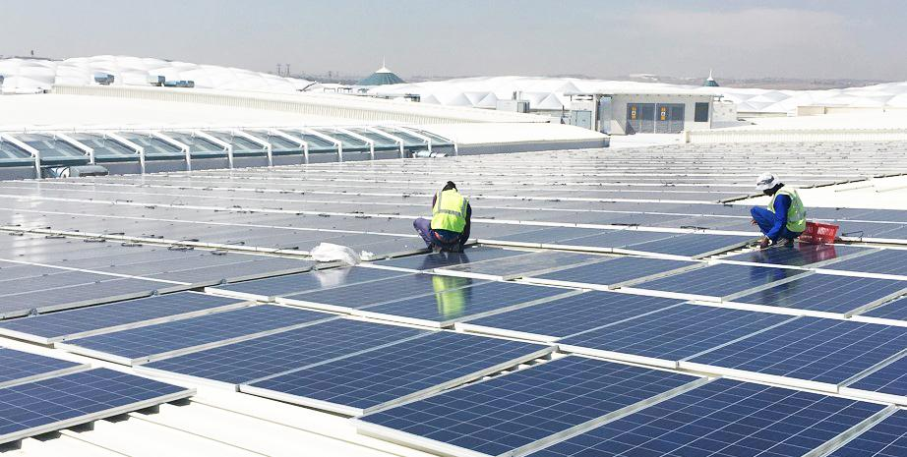

# Introduction

Due to increases in the price of electricity from the national grid and a steady decline in the price of decentralised generation options such as solar PV small-scale embedded generation (e.g. ‘rooftop’ type systems), decentralised generators are becoming financially more attractive in South Africa. Increasingly such systems are being installed by businesses and residences. It is therefore important that approval procedures and standards are established by municipal distributors to regularise this fast changing situation.

Municipal distributors are legally obliged to ensure that distribution grid power quality is maintained and safety standards are upheld to protect municipal staff working on the network, to protect the public in general, and to protect municipal infrastructure. Also, the potential revenue impact of accelerating EG installations needs to be managed. This requires that specific EG tariffs are introduced.

Municipalities are obliged to provide open and non-discriminatory access to embedded generators according to the Distribution Code, and also are moving to embrace low-carbon energy and green economic growth opportunities. Municipalities play a vital role in facilitating the growth of the EG market. A user-friendly framework around installation application and approval is important in this regard. Such a framework will also minimise systems being installed without permission, thereby potentially not meeting required safety and quality standards.

This document outlines the municipal requirements and processes for prospective EG installations to connect to the municipal electrical network such that the above factors are balanced. The focus is on SSEG, although broad guidance is provided for larger generators.

## Connecting larger generators to the distribution grid

This document covers small-scale embedded generators, with a detailed focus on generators falling under the simplified connection criteria assessment method (see Table 1). Larger generators typically require Grid Impact and/or Grid Code compliance assessments.

*Table 1: Summary of connection assessment requirements for small- and large-scale generators*

|  |  |  |  |  |
| --- | --- | --- | --- | --- |
| Generator characteristics | | | Connection assessment method | |
| Scale | Size | LV or MV connected generator | Simplified criteria (NRS097-2-3) | Grid studies |
| Small-scale (up to 1MVA) | 0-1MVA | LV connected | ✓ | 🗶  (if complies with  NRS097-2-3) |
| MV connected | 🗶 | ✓ |
| Large-scale (>1MVA) | >1MVA | LV or MV | 🗶 | ✓ |

Large generators and others requiring further grid studies, including all Independent Power Producers (IPPs), should obtain guidance from the municipality, such as:

* Guide for Municipalities on Processing Embedded Generator Applications 1 MW and Larger Grid Impact Study Specification Guide

Generic versions of the above guidance documentation is available at [www.sseg.org.za](http://www.sseg.org.za).

# Indemnity, Legal Requirements & Curtailment

## Legal and Illegal Connections to the municipal electrical network

Customers wishing to connect SSEGs to the municipal electrical network are required to follow the normal application procedure as detailed in this document and comply with the regulations, specifications and standards listed herein.

The Municipality’s Electricity Supply By-Law (as promulgated) and national regulations state that no electrical generation equipment may be connected to the municipal electrical network without the express consent of the Municipal Electricity Distributor.

Failure to obtain this consent constitutes an offence which could lead to a fine and/or imprisonment.

Furthermore, the installation may also be in contravention of the Occupational Health and Safety Act (1993), for which punitive sanctions also apply.

Customers found to have illegally connected an SSEG installation to the municipal electrical network (either before or after their electricity meter) shall be instructed to have the installation disconnected from the municipal electrical network. Should the customer fail to have the SSEG disconnected from the municipal electrical network, the Municipality will disconnect the electricity supply to the property.

In cases where unauthorised reverse feed-in takes place which results in the meter reversing to the benefit of the customer, the municipality may institute action to recover lost revenue and relevant punitive fines will be applicable.

No exemption from any of the Municipality’s requirements shall be granted for “retrospective applications”.

## Generation Curtailment

In the event of operating conditions resulting in municipal electrical network parameters not meeting statutory minimum quality-of-supply standards it may become necessary to impose peak generation limits on embedded generator installations. It is expected that these limitations would be of a temporary nature, applied only during abnormal system conditions or low load periods.

## Right to adapt rules & regulations

In the event of provincial or national legislative changes to the regulatory environment, or other technical developments, it may become necessary to implement changes to the municipal requirements which SSEGs are to comply with. The Municipality will take into account the implications for existing customers of such changes, and will require these only where grid safety or other important criteria are potentially compromised. All SSEGs, new and existing, will be obliged to comply with such changes, and will do so at their own cost.

## Right to deny access

On receipt of a complete application for an SSEG installation, the Municipality needs to check that, amongst other considerations, the SSEG installation can be accommodated on the municipal electrical network and that the total SSEG capacity of the municipal electrical network has not been exceeded, considering parameters in the NRS097-2-3 and other applicable standards. Equipment should not be purchased prior to obtaining written approval from the Municipality to commence, as approval of the SSEG as proposed by the applicant is not guaranteed and the Municipality shall not be held liable for equipment expenses in such cases.

## Unsuccessful applications

Where proposed SSEG systems are not approved by the Municipality, the Municipality will provide information to the customer on amendments to the proposed system required, and/or advise on conditions to be met, for it to be acceptable to the Municipality.

## Application processing timeframes

The Municipality will aim to assess applications for SSEG submitted and respond to applicants within 20 working days. Where applications are more complex leading to delays or require further studies, customers will be notified accordingly within this timeframe.

## Recourse for the customer

Where the Customer feels they have been unfairly dealt with by the Municipality, they should address their complaint to the Municipality in writing, or failing a suitable response, they may submit their complaint to NERSA in writing.

## Contract with the municipality

All SSEG customers are required to enter into an SSEG contract with the municipality. The document ***General Terms and Conditions: Contract for Connection of an Embedded Generator*** is available on the municipal website or from municipal Energy office at the Engineers department. In signing the SSEG Application Form, the customer agrees to be bound by the terms and conditions in this document.

## Transfer/change of ownership

If a transfer of the property and/or change of ownership of the electricity accountholder takes place, the new owner needs to sign the declaration in Annex B, which must be submitted to the Energy office.

Alternatively the SSEG installation shall be decommissioned as set out in paragraph 3.14.

# General Guidelines - Small Scale Embedded Generators

This section covers important considerations in terms of the Municipality’s SSEG rules and regulations that apply to all customers, including residential, commercial and industrial customers, who wish to connect an SSEG system.

## Registration or Generation licence

In terms of the Electricity Regulation Act (2006), any person that owns or operates a generation facility is required to obtain a generation licence to be issued by NERSA unless otherwise exempt as per Schedule 2 of the Act. Table 2 clarifies NERSA license and registration requirements.

*Table 2: NERSA Requirements for different size systems (January 2023 revision of ERA Schedule 2)*

|  |  |  |
| --- | --- | --- |
| System size\* | NERSA license? | NERSA registration? |
| Any size EG with self-consumption (can also export, but no wheeling) | 🗶 | 🗶 |
| EG for wheeling up to 100kW | 🗶 | 🗶 |
| EG for wheeling over 100kW | 🗶 | ✓ |

\* - applies whether the EG has storage or not

If a generation licence or registration is required in terms of the Electricity Regulation Act (2006), then it is the customer’s responsibility to interact with NERSA in this regard. The Municipality is obliged to report to NERSA on a regular basis regarding all municipal electrical network connected generation and it is also obliged to disconnect generators that are not adhering to regulations.

## Self-consumption vs IPPs (pure generators).

This document focuses on embedded generators which are largely for self-consumption. Independent Power Producers (IPPs) or ‘pure generators’ (where there is no self-consumption) generally will automatically require grid impact studies, and, if they intend to wheel power, will fall under any wheeling policies or regulations of the municipality. Pure generators not wheeling power but receiving export credits from the municipality will also be subject to by MFMA conditions (such as a transparent and competitive procurement process).

## Exporting electricity

Municipal requirements regarding embedded generators exporting power back onto the network are as follows:

Export freely, but remain a net consumer in Rand terms:

The is no technical limit to exporting electricity. But the export credit Rand amount may not result in a net payment to the customer in the energy account (i.e. excluding fixed demand charges). The customer is advised to size their systems appropriately.

## Wheeling.

All generators wishing to connect to the municipal network must obtain permission to connect as described in this document, whether wheeling or not. For generators wishing to wheel electricity, the municipality should be approached regarding whether a process for this is in place, and contractual and other arrangements to be complied with.

**Generators may not fall under both embedded generator export tariffs and wheeling financial arrangements**.

## Applicable technical standards

Most of the technical requirements that SSEGs are required to comply with are covered in the following standards and specifications:

1. NRS 097-2 series: Grid interconnection of embedded generation: Part 2 Small Scale Embedded Generators, in particular[[1]](#footnote-1):
   1. *NRS097-2-1: Utility interface*
   2. *NRS097-2-3: Simplified utility connection criteria for low-voltage connected generators*

In addition, SSEG installations are to comply with the following standards, legislation and regulations:

1. South African Renewable Power Plant Grid Code (although the NRS 097-2 series cover most issues relevant to SSEG)
2. NRS 048: Electricity Supply – Quality of Supply
3. SANS 10142-1 and 10142-1-2: The wiring of premises (as amended and published)
4. SANS 474 / NRS 057 : Code of Practice for Electricity Metering
5. Municipal Electricity Supply by-law

## Testing of Inverters.

Until such time as a SABS mark is issued for inverters, the Municipality shall require proof in the form of test certificates, of type tests having been successfully carried out by a third party testing authority certifying compliance of the inverters with NRS097-2-1 (and NRS097-2-2 when published). The use of inverters without such certification is not permitted, both in new and existing installations. The installation of reverse feed blocking does not exempt the customer from providing the NRS097-2-1 certification.

In general, the test certificate must be for the most recent version of NRS097-2-1. The municipality reserves the right not to accept test certificates for old versions of NRS097-2-1.

The certification body must be SANAS accredited or be recognised by the International Laboratory Accreditation Co-operation (ILAC) or the International Accreditation Forum (IAF) in terms of ISO/IEC 17025:2005 for photovoltaic systems. The accreditation bodies must provide accreditation documentation for the specific test location.

**The customer should require the inverter supplier to provide the necessary certification before the equipment is purchased**.

## Islanding / Anti-Islanding installations

All SSEG installations are required to have an anti-islanding function (immediate disconnection when there is a general power outage) as stipulated in the NRS 097-2-1. Certification to this effect is required of inverters (see 3.6 Testing of Inverters).

Should the inverter or SSEG installation have the facility to both comply with the NRS 097-2-1 requirements for grid-connected systems (including anti-islanding requirements) AND operate in “islanded mode” (or “off grid” mode) where the SSEG installation supplies power to a portion of the customer’s electrical grid during a general power outage, the islanded system shall be effectively isolated from the municipal electrical network during islanded mode operation.

If the SSEG installation is to be configured as a standby supply after isolating from the municipal electrical network (in which case it becomes an ‘alternative supply’, not an embedded generator any longer) using a break-before-make changeover switch, a registered person in terms of the Electrical Installation Regulations (2009) shall issue a Certificate of Compliance to the owner if the generator is to be connected to the existing internal wiring of the property. Requirements of SANS 10142-1 apply.

## Battery or other Storage.

Battery or other storage may be included in the SSEG configuration. Where it is connected in standby power supply mode (i.e. it is not configured to provide power in parallel to the SSEG but only to operate in islanded mode) the provisions for ‘island mode’ generators in Section 3.7 Islanding / Anti-Islanding installations apply.

Where storage is connected such that it can provide power onto the network, it shall do so via an NRS097-2-1 certified inverter. If this is achieved via a separate storage/battery inverter (even only to feed into the customers wiring which is in turn connected to the municipal network), the storage/battery inverter shall be NRS097-2-1 certified, and evidence of such compliance provided to the municipality.

Battery charging current limits are applicable to reduce cold load pickup, and are covered in the NRS097-2-3.

## Hybrid inverters operating in islanded (off-grid) mode.

Inverters which can be operated in grid-tied or islanded (off-grid) mode, but where physical wiring connections with the grid exist (e.g. via the distribution board), are considered grid-tied SSEG systems and require municipal permission as described in this document. This applies even if they are being operated in off-grid (islanded) mode. Only where there is no physical wiring connection to the grid, direct or indirect, is it not considered an embedded generator.

## Fire safety and emergency shut-off switch

Emergency disconnection switching shall be in accordance with NRS 097-2-1.

## Dead Grid safety Lock

Dead Grid Safety Lock shall be in accordance with SANS10142-1-2 (as published).

## Qualified installers.

The municipality recommends that customers installing solar PV SSEG use industry accredited installers under a third party quality assurance such as PV Green Card: A SAPVIA (South African Photovoltaic Industries Association) endorsed programme to ensure the quality and safety of PV installations ([www.pvgreencard.co.za](http://www.pvgreencard.co.za)), or P4 quality assurance certification (<https://pqrs.co.za/the-pv-quality-assurance-program/>).

SSEG Sign-off on Commissioning

Until SANS 10142-1-2 ‘*The wiring of premises; Specific requirements for embedded generation installations connected to the low voltage distribution Network in South Africa*’ is published, upon commissioning, all SSEGs shall be signed off as follows:

|  |  |
| --- | --- |
| **SIGN-OFF OPTION 1:**  Up to 30kVA -  (for PV) Industry Accredited Installer\* signoff  OR  ECSA registered Pr Eng or Pr Tech Eng  Over 30kVA –  ECSA registered Pr Eng or Pr Tech Eng | ***Tick chosen option*** |
| **SIGN-OFF OPTION 2:**  Up to 100kVA -  (for PV) Industry Accredited Installer\* signoff  OR  ECSA registered Pr Eng or Pr Tech Eng  Over 100kVA –  ECSA registered Pr Eng or Pr Tech Eng | ***Tick chosen option*** |
| **SIGN-OFF OPTION 3:**  Up to 1MVA (all SSEG)  (for PV) Industry Accredited Installer\* holder signoff  OR  ECSA registered Pr Eng or Pr Tech Eng on all systems | ***Tick chosen option*** |
| **SIGN-OFF OPTION 4:**  Up to 1MVA (all SSEG)  ECSA registered Pr Eng or Pr Tech Eng on all systems | ***Tick chosen option*** |
| **SIGN-OFF OPTION 5**: (own text) | ***Tick chosen option*** |

*\* - such as PV Green Card*

Upon the publishing and implementation of the SANS10142-1-2, a registered person in terms of the Electrical Installation Regulations (1993) with appropriate knowledge and experience in applying the SANS10142-1-2 (acceptable to the Municipality) will be adequate to sign-off all SSEGs.

## Decommission of SSEG system.

The Municipality requires notice of any SSEG installation which has been decommissioned. The SSEG installation must, at the owners' cost, be disconnected from the municipal electrical network by the removal of the wiring that connects the SSEG with the municipal electrical network and a decommissioning report filed (on the prescribed form) – including the provision of a Certificate of Compliance to confirm disconnection.

## Eskom grid connection

Customers residing within the municipal boundaries, but located in Eskom’s area of supply, need to apply to Eskom for consent to connect the SSEG installation to the Eskom electrical grid. The municipality will not be involved in this process.

## SSEG applications from sub-tenants, complex residents or other non-municipal customers.

The municipality will only engage with applications from their existing or new customers. Where an SSEG installation is intended but the person purchases electricity from a re-seller (e.g. landlord/lady, complex body corporate), for example, not directly from the municipality, the application will need to come from the re-seller who is a registered municipal electricity customer.

## Off-grid system

Stand-alone generators (not connected to the municipal electrical network in anyway) do not need permission from the Municipal Electricity authority. However, approvals from other Departments may still be necessary (e.g. Building Control Section), and it is the responsibility of the owner to comply with any such requirements.

## Advice for the customer

### Load profile management to maximise benefit to the customer

Customers will generally find it most financially beneficial to ensure that they utilise as much of the generated electricity as they can and avoid or minimise export/reverse power flow. With solar PV SSEG, for example, with a residential SSEG installation, loads such as geysers and pool pumps could be shifted to the middle of the day when solar generation is typically at its highest – between mid-morning and mid-afternoon.

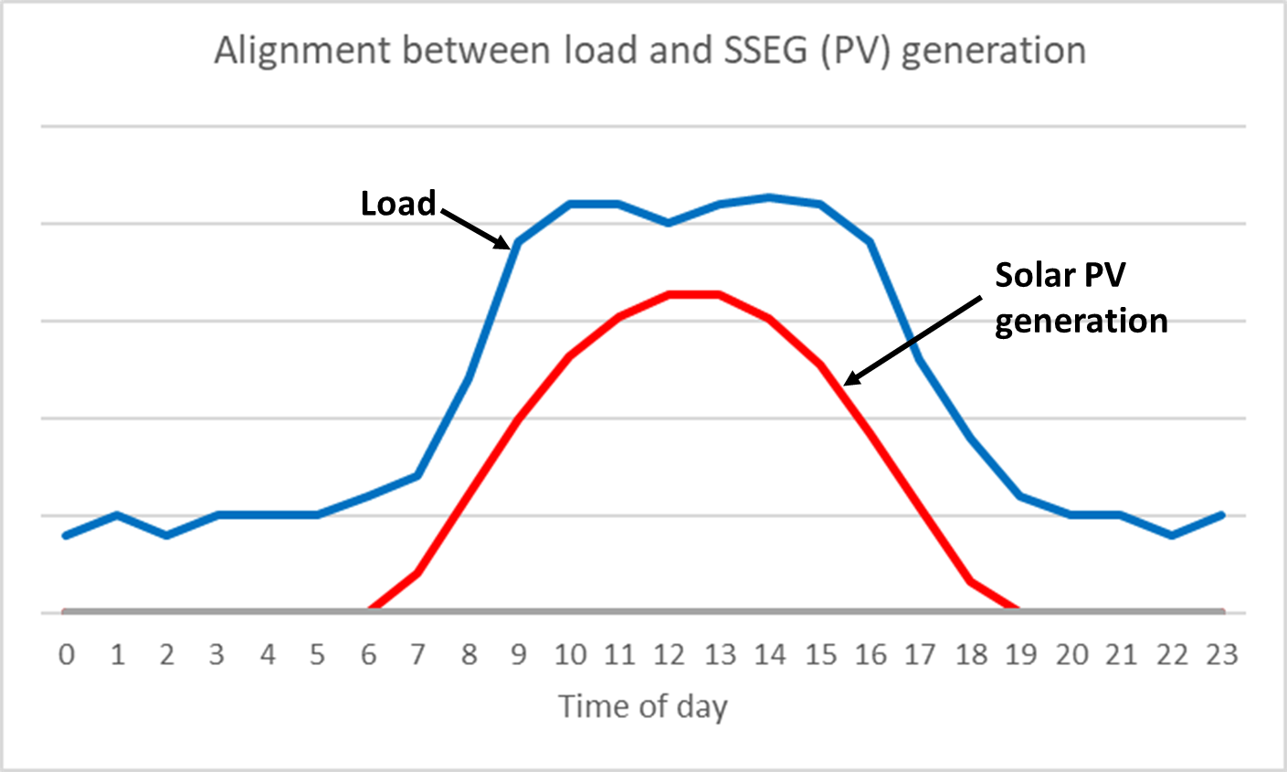

*Figure 1: Good alignment between load profile and SSEG (PV) generation*

*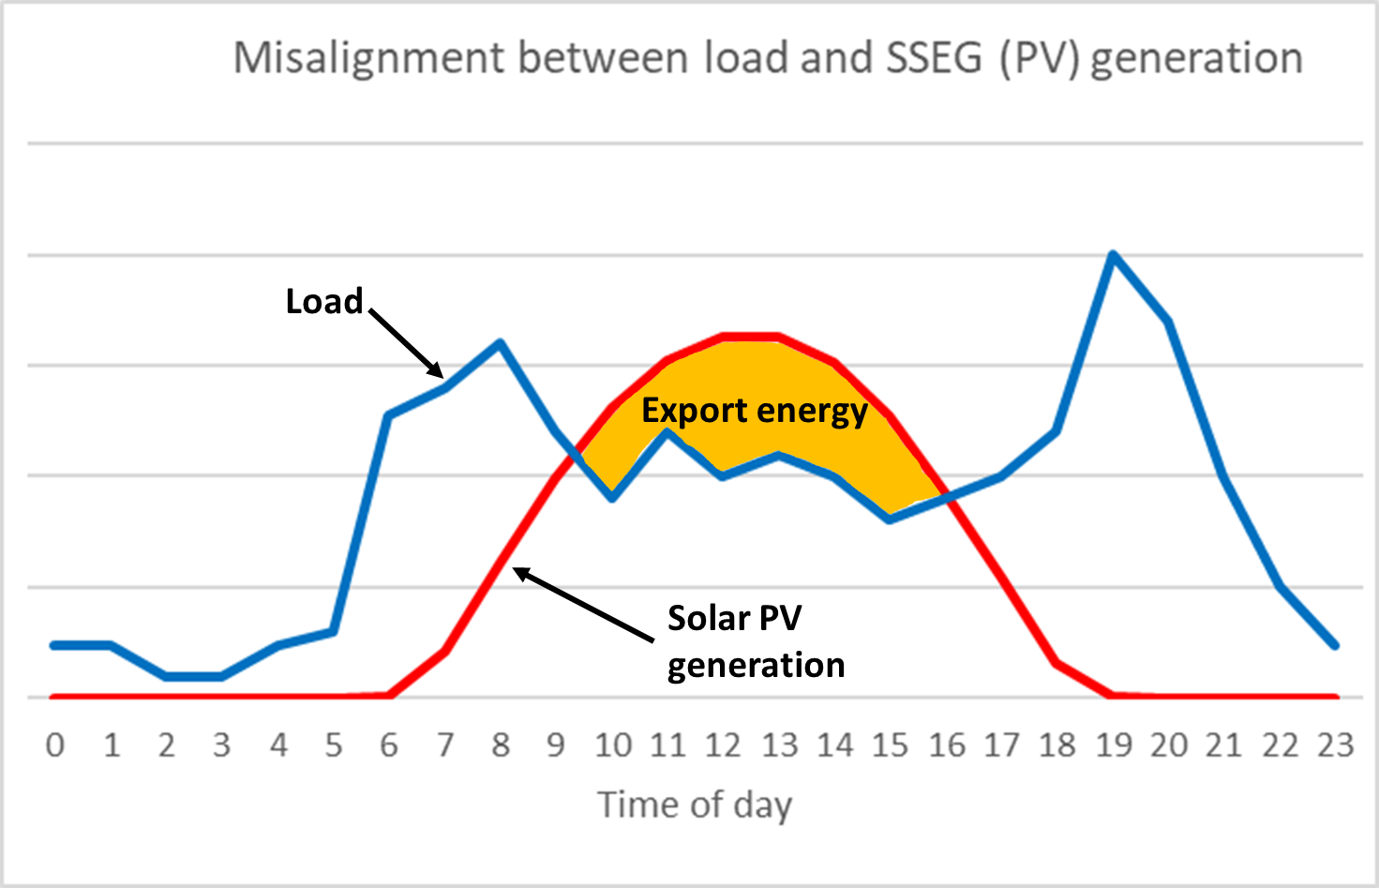*

*Figure 2: Poor alignment between load profile and SSEG (PV) generation).*

### Roof strength for PV installations

Customers are responsible to ensure that their installer has checked the load (weight) bearing capacity of the roof on which the PV panel installation is to take place. This may involve obtaining an engineer’s report on the roof strength. Note that in normal circumstances roof design strength is adequate to accommodate PV panels.

### Installer experience and accreditation

Customers are advised to check that the installer they intend to use has adequate competence and experience to undertake such projects. For solar PV SSEG third party quality assurances such as PV Green Card or P4 can be used:

* PV Green Card: A SAPVIA (South African Photovoltaic Industries Association) endorsed programme to ensure the quality and safety of PV installations ([www.pvgreencard.co.za](http://www.pvgreencard.co.za)).
* P4 quality assurance certification (<https://pqrs.co.za/the-pv-quality-assurance-program/>).

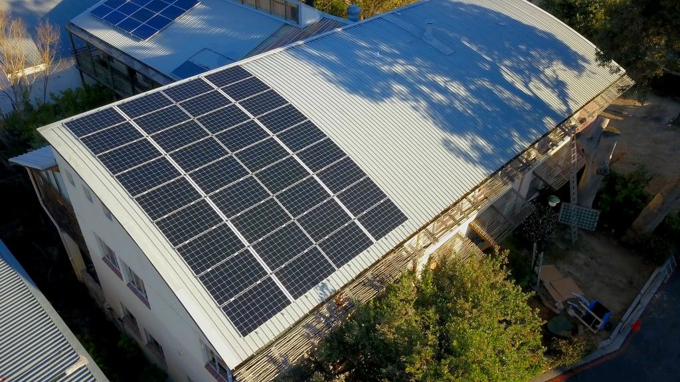

# Metering

## Metering installation and reverse power flow/ feed-in to the municipal electrical network

|  |  |
| --- | --- |
| **METERING OPTION 1**  Customers installing SSEG with reverse flow blocking do not need to install bi-directional meters. However, a prepaid meter must be in place or installed.  Customers installing SSEG with the ability to export power shall have an approved bi-directional meter. The Municipality shall provide and install the requisite meter at the customer’s cost. | ***Tick chosen option*** |
| **METERING OPTION 2**  All customers installing SSEG, whether with reverse feed blocking or not,shall have an approved bi-directional meter. The Municipality shall provide and install the requisite meter at the customer’s cost. | ***Tick chosen option*** |
| **METERING OPTION 3**: (own text – e.g. customised to be consistent with your municipal metering policy) | ***Tick chosen option*** |

Where the municipality has not yet implemented tariffs with export credits, reversed feed will be allowed on systems so enabled, but will not be compensated for (note that this is a temporary situation pending the operationalising of SSEG tariffs).

**Conventional credit or prepayment meters are not allowed to run backwards.**

## Adaption of electrical metering installation

The Municipality reserves the right to require customers moving onto an SSEG tariff to adapt their electrical installations in such a way that the metering is located in a kiosk in the road reserve. The municipality will inform prospective SSEG customers accordingly should this be required.

## Refunds of electricity already pre-purchased

Where applicants currently have Prepayment meters (PPM), these will need to be replaced with meters appropriate for SSEG systems and tariffs. Refund of Prepayment meter units when a customer changes to the SSEG tariff and has an appropriate meter installed will not be given. The customer should therefore delay the installation of an SSEG-appropriate meter until the units purchased are used. Otherwise units purchased on the PPM will be forfeited.



# SSEG connection criteria

Simplified SSEG connection criteria are specified in the NRS 097-2-3 (2023), and applications for systems that fall within these parameters are likely to be easily processed by the Municipality, and only in rare cases will require grid impact studies in their assessment. Such parameters include:

* Systems not larger than 1000kVA
* Connecting to a LV network

Applications to connect SSEG installations which exceed the parameters of the NRS097-2-3 will also be accepted by the Municipality, but may require specialist grid-impact studies in their assessment. The Municipality will advise the customer of such needs after the application form is received.

There are different criteria for simplified connection in shared and dedicated LV feeders, as described below (for details see the relevant sections of the NRS097-2-3):

***Note that the below is a summary of parts of the NRS097-2-3 (2023), and is provided for information purposes. The parameters and criteria in the latest version of the NRS097-2-3 may differ from the below and, where this is the case, they supersede the below information. It is therefore important to consult the latest version of the NRS097-2-3 as the criteria therein will be used to assess the SSEG application.***

## Shared LV feeders

The NRS 097-2-3 specifies that the maximum individual limit on a shared LV feeder (which applies to most small commercial and residential situations) is as follows:

* SSEG nameplate power rating shall not exceed the consumer’s NMD (or UIC – Utility Installed Capacity)[[2]](#footnote-2)
* SSEG maximum export capacity shall not exceed 25% of the customers NMD
* Maximum battery/storage charging current shall not exceed 25% of the NMD[[3]](#footnote-3)

The following SSEG size limitations are derived from NRS 097-2-3 for Shared LV connections.

*Table 3: SSEG size limitations - NRS 097-2-3 for Shared LV connections*

| **Service connection** | | | **SSEG parameters** | | |
| --- | --- | --- | --- | --- | --- |
| No phases | Service circuit breaker (A) | Maximum demand (NMD) (kVA) | Max export capacity (kVA) (25%) | Max nameplate power rating (kVA) (100%) | Max battery charging current (per phase) (A) (25%) |
| 1 | 40 | 9.2 | 2.3 | 9.2 | 10 |
| 1 | 60 | 14 | 3.5 | 13.8 | 15 |
| 1 | 80 | 18 | 4.6 | 18.4 | 20 |
| 3 | 40 | 28 | 7 | 28 | 10 |
| 3 | 60 | 41 | 10 | 41 | 15 |
| 3 | 80 | 55 | 14 | 55 | 20 |
| 3 | 100 | 69 | 17 | 69 | 25 |
| 3 | 125 | 86 | 22 | 86 | 31 |
| 3 | 150 | 104 | 26 | 104 | 38 |
| 3 | 175 | 121 | 30 | 121 | 44 |
| 3 | 200 | 138 | 35 | 138 | 50 |
| 3 | 225 | 155 | 39 | 155 | 56 |
| 3 | 250 | 173 | 43 | 173 | 63 |
| 3 | 275 | 190 | 47 | 190 | 69 |
| 3 | 300 | 207 | 52 | 207 | 75 |
| 3 | 325 | 224 | 56 | 224 | 81 |
| 3 | 350 | 242 | 60 | 242 | 88 |
| 3 | 375 | 259 | 65 | 259 | 94 |
| 3 | 400 | 276 | 69 | 276 | 100 |

*Notes to table:*

* *To determine if it is a single-phase or three-phase connection, check the main circuit-breaker on the distribution board. A single-phase supply will generally have a single main circuit-breaker, and a three-phase a triple main circuit-breaker. If in doubt consult an electrician.*
* *‘****Maximum nameplate power rating’*** *refers to the total output capacity of the generator. For PV systems in particular, this refers to the maximum output of the inverter. Due to system losses this is typically 10 to 20% lower than the maximum output of the PV panels, which is specified in DC kilo-Watt-peak (kWp). The system designer/installer will provide guidance here.*

## Dedicated LV feeders

On dedicated LV feeders the maximum generator size is limited to 75% of the NMD.

The NRS 097-2-3 specifies that the maximum individual limit on a Dedicated LV feeder is as follows:

* SSEG nameplate power rating shall not exceed the consumer’s NMD (or UIC – Utility Installed Capacity)[[4]](#footnote-4)
* SSEG maximum export capacity shall not exceed 75% of the customers NMD
* Maximum battery/storage charging current shall not exceed 25% of the NMD[[5]](#footnote-5)

The following SSEG size limitations are derived from NRS 097-2-3 for Dedicated LV connections.

*Table 4: SSEG size limitations - NRS 097-2-3 for Dedicated LV connections*

| **Service connection** | | | **SSEG parameters** | | |
| --- | --- | --- | --- | --- | --- |
| No phases | Service circuit breaker (A) | Maximum demand (NMD) (kVA) | Max export capacity (kVA) (75%) | Max nameplate power rating (kVA) (100%) | Max battery charging current (per phase) (A) (25%) |
| 3 | 125 | 86 | 65 | 86 | 31 |
| 3 | 150 | 104 | 78 | 104 | 38 |
| 3 | 175 | 121 | 91 | 121 | 44 |
| 3 | 200 | 138 | 104 | 138 | 50 |
| 3 | 225 | 155 | 116 | 155 | 56 |
| 3 | 250 | 173 | 129 | 173 | 63 |
| 3 | 275 | 190 | 142 | 190 | 69 |
| 3 | 300 | 207 | 155 | 207 | 75 |
| 3 | 325 | 224 | 168 | 224 | 81 |
| 3 | 350 | 242 | 181 | 242 | 88 |
| 3 | 375 | 259 | 194 | 259 | 94 |
| 3 | 400 | 276 | 207 | 276 | 100 |
| 3 | 500 | 345 | 259 | 345 | 125 |
| 3 | 630 | 435 | 326 | 435 | 158 |
| 3 | 800 | 552 | 414 | 552 | 200 |
| 3 | 1000 | 690 | 518 | 690 | 250 |
| 3 | 1250 | 863 | 647 | 863 | 313 |
| 3 | 1500 | 1035 | 776 | 999 | 375 |

*Notes to table:*

* *‘****Maximum nameplate power rating’*** *refers to the total output capacity of the generator. For PV systems in particular, this refers to the maximum output of the inverter. Due to system losses this is typically 10 to 20% lower than the maximum output of the PV panels, which is specified in DC kilo-Watt-peak (kWp). The system designer/installer will provide guidance here.*

## Phase balancing

If SSEG maximum export capacity is 4.6 kVA or less, a single-phase inverter can be installed even if the customer has a three-phase connection. Systems with max export above 4.6 kVA are required to be balanced across the phases[[6]](#footnote-6). In general phase unbalance should not exceed 4.6kVA, including consideration of load distribution between phases.

## Cumulative SSEG capacity and impact on LV and MV networks

Should the cumulative installed capacity of an SSEG installation be such that it may impact negatively on local LV or MV network functioning, as per the stipulations of NRS097-2-3, the municipality will not allow further SSEG connections until they can be demonstrated to be undertaken without such negative impact. Increasing the SSEG carrying capacity on feeders may require network hardware upgrades. Specialist grid impact studies may be requested of the new SSEG applicant to demonstrate the impact, even if the individual system size falls within the NRS097-2-3 parameters.

## Grid impact studies

Should the SSEG being applied for cause the parameters in the NRS097-2-3 (Simplified Connection Criteria) to be exceeded, either (1) the system should be modified to fall within these parameters, or (2) a Grid Impact Study is likely to be requested by the municipality before the application can be assessed. Content and coverage of such a study may vary depending on the circumstance.

Should such impact studies be required by the municipality, details of method, data and payment requirements should be discussed with the municipality. Responsibilities of the municipality (who has the network data) and the customer in completing the study will also need to be clarified. Even in the case of SSEG with no reverse feed, scenarios such as Load Rejection may still need to be assessed in the study.

Where network hardware upgrades are found to be necessary in order to accommodate the proposed SSEG, costs may be for the customer’s account. This should be discussed with the municipality.

Further information on Grid Impact Studies is given in Annex A.

# SSEG Tariffs

The Municipal SSEG tariffs, once approved by NERSA, will be available on the municipal website or from the electricity department offices on request. Tariffs are updated annually. Where tariffs with export credits have not yet been implemented by the municipality, reverse feed will be accepted but will not be compensated for (note that this is a temporary situation pending the operationalising of SSEG tariffs).

General information on SSEG tariffs is given below:

## Residential SSEG Tariff

The Residential SSEG tariff comprises the following parts:

**Fixed charge**: This comprises (1) a Network charge, which ensures that fixed costs associated with maintaining and operating the municipal electrical network are recovered through appropriate charges, and (2) a Service charge that covers the fixed costs associated with providing a retail service network (metering, billing, customer call centre) are recovered through appropriate service charges.

**Energy charge** (c/kWh): The variable cost associated with the volume of energy consumed is recovered through appropriate charges. This is billed on a per kWh basis and may be simple (Flat or Inclining Block tariff) or complex (Time of Use or other tariff).

**Export (Feed-in) credit** (c/kWh): The compensation to the customer for energy provided back onto the network.

## Commercial and Industrial SSEG Tariff

Commercial and industrial customers that are on tariffs which already have a fixed service charge and network demand charge will retain a similar tariff structure, and an export (feed-in) generation tariff credit will be added for reimbursement for energy exported onto the municipal electrical network. Customers on a tariff that does not include fixed service/network charge and demand charge will be changed to an appropriate tariff.

Commercial and Industrial customers should note that the demand charge component of the tariff is unlikely to change after the installation of the SSEG because the monthly maximum demand is unlikely to reduce due to the regular occurrence of cloudy weather.

## Billing Period

The service charge along with charges for consumption and credits for feed-in will be billed monthly. Any credits from excess SSEG generation in a particular month will be rolled over to the following month. Credits will not be paid out to the customer.

## Connection Costs

The Municipality may stipulate a connection cost to be paid by SSEG customers prior to system generation approval. This will be reflected in the currently applicable tariff and charge schedule.

## Increased Costs

The Municipality bares no responsibility should the customer’s electricity bill increase due to changes in the applicable tariff. It is up to the customer to ensure that they understand the financial implications of having an SSEG installation installed and the applicable tariffs.

## Time-of-Use Tariffs

Time of Use tariffs are considered best practice for both consumption and export (feed-in) tariffs, and municipalities may increasingly move all customers to such tariffs in future.

# Approvals required from other municipal departments

Where relevant, approvals required of other municipal departments are to be obtained prior to submission of the SSEG application form, and reflected on the form.

## Buildings/Planning department

No building plans are required to be submitted provided the SSEG installation does not project more than 1.5 m, measured perpendicularly, above the roof and/or not more than 600mm above the highest point of the roof. If the above parameters are exceeded then full building plans, including an engineer’s endorsement, are required. A relaxation in terms of the Zoning Scheme Regulations may also be required under either one or both of the above circumstances.

**Ground-mounted systems**: no building plans are required to be submitted provided the panel(s) in its installed position does not project more than 2.1 metres above the natural/finished ground level. Full building plans are required where any part of the installation projects more than 2.1 metres above the ground level.

## Other Approvals

SSEG installations covered by this document generally do not require Environmental Impact Assessments.

For generators that produce noise or air pollutants (e.g. diesel generators), approval from Municipal departments is required (e.g. Health, Environment).

# What payments may be due by the customer?

The customer is responsible to pay for the following:

* The supply and installation of meters (in accordance with the Municipality’s metering policy)
* Connection charges (if applicable)
* Specialist municipal electrical network impact studies – if required (details of payment amounts are to be discussed with the municipality)
* Any changes required to the municipal electrical network upstream of the connection point as a result of the SSEG installation.
* Specialist test that are required, e.g. Inverter testing
* Any other costs associated with obtaining approval for the SSEG connection to the municipal grid

# SSEG application process

The *Application for the Connection of Embedded Generation* form shall be completed for all applications to connect an SSEG installation to the municipal electrical network. The forms are available on the Municipality’s website or from the Energy office in the Engineers Department.

* **Step 1: Obtain the Application Form**
  + Visit the Municipality’s website and download the relevant application form/s or request the forms from the Energy office in the Engineers Department.

* **Step 2: Complete application form for the connection of SSEG**
  + The Municipality requires that the application form/s be signed by the current electricity customer/account holder.
  + Details of the proposed installer shall also be provided.
  + The customer may need support from the proposed installer or registered personnel in completing the application form.
  + By signing the application form the customer agrees to the *General Terms and Conditions:* *Contract for Connection of an Embedded Generator* (this document is available on the municipal website or on request from the Energy office in the Engineers Department).
* **Step 3: Obtain permission from other Municipality departments**
  + The electricity department may require prior approval of the proposed SSEG installation from other departments as stipulated in the form (e.g. buildings department) if relevant. All relevant approvals must be reflected in or submitted with the application form.
* **Step 4: Submit completed application form/s and attachments**
  + Form/s shall be submitted to the relevant contacts at the Engineers department.
  + Attachments to the application include an initial design circuit diagram (for >100kVA systems) and inverter NRS097-2-1 certification.
* **Step 5: Installation commencement upon approval from the municipality**
  + After due consideration of the application, the applicant will be informed in writing whether the application has been successful or not.
  + If further information or grid studies are required by the municipality, the applicant will be notified thereof.
  + Once notified in writing of a successful application, the applicant may commence installation (it is advised that the applicant does not pay for any equipment until municipal approval to install is granted in writing, as such approval is not guaranteed).
* **Step 6: Commissioning and documentation to be submitted to the electricity department.**
  + Once installation is complete, commissioning of the SSEG installation shall be undertaken by a competent person, who shall complete and sign off the SSEG Installation Commissioning Report.
  + In addition to the SEG Installation Commissioning Report, there is a list of other documentation specified on the Commissioning Report for submission with the Report, including:
  + Final as-built circuit diagram
  + Inverter type test certificate according to NRS 097-2-1.
  + An electrical installation Certificate of Compliance as per SANS 10142-1 (and SANS 10142-1-2 when published).
  + All completed documentation shall be submitted to the relevant electricity department office.
* **Step 7: Inspection of installation if necessary**
  + The Municipality shall inspect the SSEG installation if they deem it necessary, although this is unlikely in the case of a residential application.
* **Step 8: Approval granted to connect to the municipal electrical network and generation commences**
  + If all of the above is satisfactory, the Municipality shall install the necessary meter, or check that such is installed.
  + Approval to connect the SSEG installation to the municipal electrical network shall be provided by the Engineers department to the customer, in writing, together with any operation and other requirements deemed necessary.
  + Once this is done, the change to the SSEG tariff shall be implemented if applicable.

# Changes to existing approved systems

SSEG installations that have previously been approved by the municipality but where changes to the SSEG are planned, will require the following:

**A new application shall be completed when the following is intended:**

* + An expansion in the SSEG capacity
  + A change in the SSEG configuration (e.g. adding storage)

**A new commissioning process needs to be undertaken, and a new Commissioning Report completed, when the following changes are made:**

* + Significant components are replaced (i.e. inverter, anti-island device, other protection equipment) but system capacity is not increased
  + A system is moved but no changes to capacity or significant components are made (i.e. inverter, anti-island device, and other protection equipment all stay the same)

# ANNEX A: Grid Impact Study Overview

In cases where an SSEG or larger EG application falls outside the simplified connection criteria in NRS097-2-3, it may be necessary to conduct grid impact studies. These studies will assess whether the grid or electrical network remains within prescribed technical limits[[7]](#footnote-7) after the connection of the SSEG. The municipality will provide specific requirements in this regard. Some general information is below.

## General grid impact studies

For most SSEG systems connecting to LV networks grid impact studies can be relatively simply undertaken – often with only hand calculations - and do not require detailed grid simulation. They can thus be undertaken without power system simulation software. More detailed guidelines on assessing such impacts can be found in [Recommended practice for assessing the connection of small generators based on renewable energy sources to low-voltage and medium-voltage municipal grids](https://www.sseg.org.za/wp-content/uploads/2019/03/Grid-Impact-Studies-P13162_SSEG_Guideline_National_V1.pdf) (Moeller & Poeller Engineering, May 2018 – Final Draft).

## Requirements for more complex Grid Impact Studies

Where more complicated grid impact studies are required, power system simulation may need to be undertaken using appropriate software.

The municipality will be required to utilise their geographic and operational knowledge of the network to determine the areas that could potentially be affected by the SSEG. In order to conduct the studies, the municipality will need to have a representative model of the network affected in the format required by the simulation software tool.

*Table 5: Grid impact studies to be conducted*

|  |  |
| --- | --- |
| Type of study | Notes |
| Loadflow   * Voltage limits (regulation) * Thermal loadings | To be undertaken for:  - Peak load, max gen  - Light load, max gen  - Peak load, min gen  - Light load, min gen |
| Voltage changes   * Generator rejection (combined impact of all embedded generation on that part of the network) | To be undertaken for:  - Peak load, max gen  - Light load, max gen |
| Short circuit studies   * Equipment ratings |  |
| Protection coordination |  |

Note: where reverse feed will never take place (i.e. reverse feed blocking acceptable to the distributor is installed), only limited impact study may be required - covering voltage changes with load / generator rejection and voltage limits/regulation.

## Grid Impact Study Specification Guide

A grid impact study specification guide is available at the below link. This may be used by a municipal distributor to specify exactly what is required in such a study. It provides a checklist of parameters to be examined as well as description of the data needs for a simulation study.

<https://www.sseg.org.za/grid-impact-study-specification-guide/>

# ANNEX B: New Owner/Account Holder Declaration

In the event of transfer of property and/or ownership, the below Declaration is to be signed by new owner / account holder:

|  |  |  |  |  |
| --- | --- | --- | --- | --- |
| **Declaration regarding the SSEG system located at:** | | | | |
| Property Erf number: |  | | | |
| Physical address: |  | | | |
| Township / Suburb / Farm |  | | Post code: |  |
| Site GPS coordinates: | Latitude (dd mm ss) | |  |  |  |  |  |  |  |  |  |  |  | | --- | --- | --- | --- | --- | --- | --- | --- | --- | --- | --- | | S |  |  | ° |  |  | ‘ |  |  |  | `´ | | | |
| Longitude (dd mm ss) | |  |  |  |  |  |  |  |  |  |  |  | | --- | --- | --- | --- | --- | --- | --- | --- | --- | --- | --- | | E |  |  | ° |  |  | ‘ |  |  |  | `´ | | | |
| Name of owner/account holder: |  | | | |
| Electricity Account Number: |  | | | |
| Telephone Number: | Land: |  | | |
| Mobile: |  | | |
| Email Address: |  | | | |
| ***Acceptance of Terms and Conditions***  *I, the Customer (Account Holder) acknowledge that I have read and understood the General Terms and Conditions: Contract for Connection of Embedded Generator and that by signing this declaration form, I agree to be bound by the General Terms and Conditions: Contract for Connection of Embedded Generator. I note that a copy of the General Terms and Conditions: Contract for Connection of Embedded Generator can be found on the Municipal website or is obtainable from the electricity department offices on request. Any amended terms and conditions found on the aforementioned website will form part of the terms and conditions of the General Terms and Conditions: Contract for Connection of Embedded Generator, to which terms I, the Customer, agree to be bound. The information provided in the SSEG Application Form accepted by the Municipality also forms part of the General Terms and Conditions: Contract for Connection of Embedded Generator.*  **Customer (Account Holder) Signoff:**    **\_\_\_\_\_\_\_\_\_\_\_\_\_\_\_\_\_\_\_\_\_\_\_\_\_\_\_\_\_\_\_ \_\_\_\_\_\_\_\_\_\_\_\_\_\_\_\_\_\_\_\_ \_\_\_\_\_\_\_\_\_\_\_\_\_\_\_\_\_\_\_\_\_\_\_**  Name Date Signature | | | | |

The declaration must be submitted to the electricity department.

1. Note that the Grid Code is the overarching technical regulatory framework applicable to all generators, however the NRS097 series covers the aspects of the Grid Code relevant to SSEG, and therefore the Grid Code does not need to be directly referred to for generators covered by NRS097 specifications. [↑](#footnote-ref-1)
2. The NRS097-2-3 uses the term UIC (utility installed capacity) in place of NMD (notified maximum demand) which is used in this document. They can be regarded as the same for the purposes on this document. [↑](#footnote-ref-2)
3. Measured on the AC terminals of the power conversion equipment [↑](#footnote-ref-3)
4. The NRS097-2-3 uses the term UIC (utility installed capacity) in place of NMD (notified maximum demand) which is used in this document. They can be regarded as the same for the purposes on this document. [↑](#footnote-ref-4)
5. Measured on the AC terminals of the power conversion equipment [↑](#footnote-ref-5)
6. See NRS097-2-3 in the case of dedicated single-phase supplies. [↑](#footnote-ref-6)
7. As a minimum these limits should be in line with the South African Grid Code (SAGC), Distribution Code and the SAGC Requirements for Renewable Power Plants [↑](#footnote-ref-7)