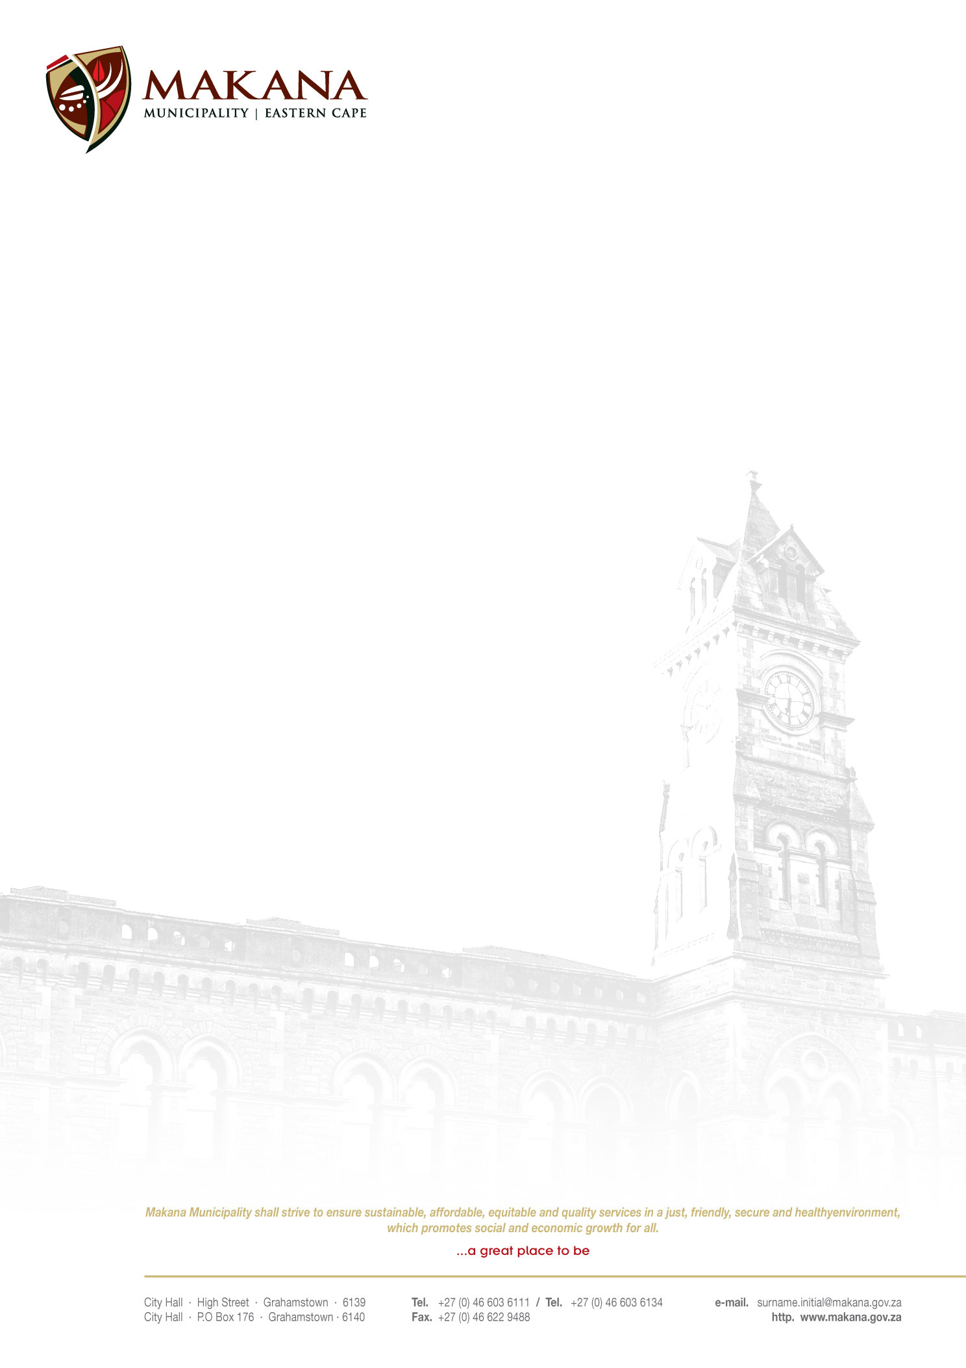

MAKANA MUNICIPALITY

REQUEST FOR QUOTATIONS
RFQ NO: 21 / 2016

SUPPLY, DELIVERY AND INSTALLATION OF A NEW TELEPHONE LINE

Makana Municipality seeks to secure services of an experienced and competent service provider to provide the following

Scope of work

- Supply, deliver and install a new telephone line at the Riebeeck East Library (26 Stand Street, Kwanomzamo Location)
- Quotation to include monthly rental with a inter branch connection with the City Hall, Finance and Housing PABX
- The quotation must be valid for a period of 15 days
- The rental must be valid for a period of 36 months
- Quotation should include traveling to the site

Duration of the Project

- Contractors must complete the work within 3 days after issuing an order

Requirements

- Suppliers must be registered on the Municipal Database (Please state your supplier number as proof of registration)
- Price must be VAT inclusive and fixed (for all registered vendors)
- A supplier must quote on all items. If a supplier does not quote on all the items they will be disqualified.
- The Municipality is not obliged to accept the lowest or any quotation;
- A firm delivery period must be indicated
- All quotations will adjudicated in terms of Council’s Supply Chain Management Policy
- The following documentation must be submitted with your quote in order to be considered, failing which will lead to disqualification;
- An original valid SARS Tax Clearance Certificate
- A valid Billing Clearance Certificate from your Local Municipality
- Copy/ies of the Company registration .e.g. CK1, CK2, Trust documents, sole provider ect.
- Original certified copies of Directors Identity Documents
- An original certified copy of the B-BBEE certificate
- Completed MBD 4 form (Declaration of interest)
- Completed MBD 9 form (Certificate of Independent Bid Determination)

- Please ensure that all returnable documentation are numbered (e.g. page 1 of 5 ect) and binded in 1 (one) document;
- The quotations must be submitted on the Letterhead of your business.
- Please ensure that the returnable documentation is placed ina sealed envelope clearly indicating the RFQ NUMBER & DESCRIPTION on the envelope.
- The quotation box is located upstairs situated in the Finance Directorate, 86 High Street, Grahamstown (During normal office hours).
- Quotations that are late will not be accepted
- Quotations per fax or e-mail will also not be considered
- The evaluation criteria is 80/20

NB: BIDDERS WHO ARE IN THE SERVICE OF THE STATE WILL NOT BE CONSIDERED

For further inquiries contact Mr. L. Klaas at 046 – 603 6111 or email Xhantibokwe@makana.gov.za

Closing date: 26 May 2016 at 12H00

MS MJ MEIRING
ACTING MUNICIPAL MANAGER

