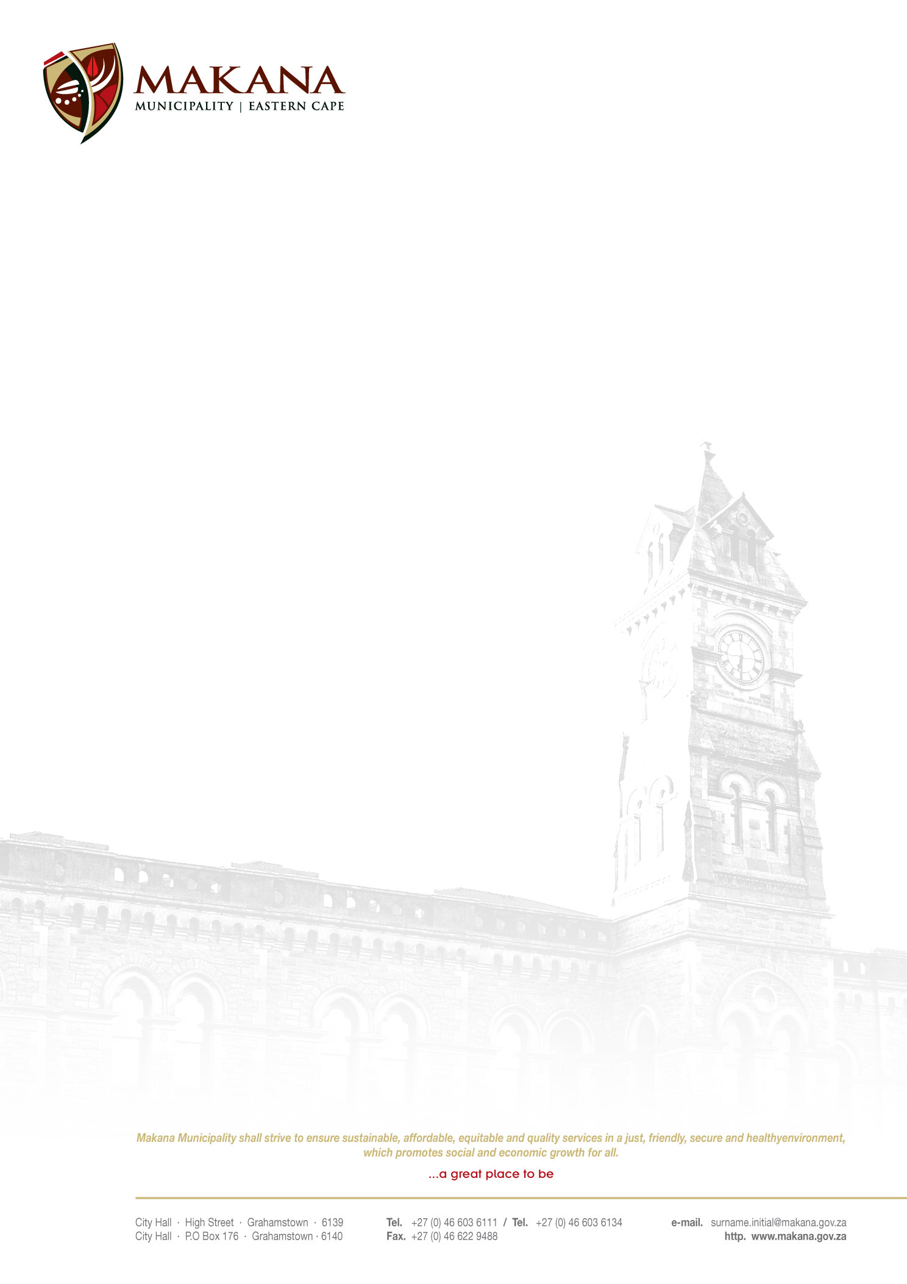

MAKANA MUNICIPALITY

REQUEST FOR QUOTATIONS
RFQ NO: 20 / 2016

SUPPLY, DELIVERY, INSTALLATION AND COMMISSIONING OF PROTECTION RELAYS

Makana Municipality seeks to secure services of an experienced and competent service provider to provide the following

The scope covers the supply, delivery, installation and commission of 1 SEL 551C protection relays.

Scope of work

- Supply, delivery, install and Commission of 1 x SEL 551C Protection relay
- Decommission of the existing relay and install blanking plates
- Install, setup and commission of protection relay and mark-up drawings
- Quotation should include traveling to the site

Duration of the Project

- Contractors must complete the work within 30 days after issuing an order

Requirements

- Suppliers must be registered on the Municipal Database (Please state your supplier number as proof of registration)
- Price must be VAT inclusive and fixed (for all registered vendors)
- A supplier must quote on all items. If a supplier does not quote on all the items they will be disqualified.
- The Municipality is not obliged to accept the lowest or any quotation;
- A firm delivery period must be indicated
- All quotations will adjudicated in terms of Council’s Supply Chain Management Policy
- The following documentation must be submitted with your quote in order to be considered, failing which will lead to disqualification;
- An original valid SARS Tax Clearance Certificate
- A valid Billing Clearance Certificate from your Local Municipality
- Copy/ies of the Company registration .e.g. CK1, CK2, Trust documents, sole provider ect.
- Original certified copies of Directors Identity Documents
- An original certified copy of the B-BBEE certificate
- Completed MBD 4 form (Declaration of interest)
- Completed MBD 9 form (Certificate of Independent Bid Determination)

- Please ensure that all returnable documentation are numbered (e.g. page 1 of 5 ect) and binded in 1 (one) document;
- The quotations must be submitted on the Letterhead of your business.
- Please ensure that the returnable documentation is placed ina sealed envelope clearly indicating the RFQ NUMBER & DESCRIPTION on the envelope.
- The quotation box is located upstairs situated in the Finance Directorate, 86 High Street, Grahamstown (During normal office hours).
- Quotations that are late will not be accepted
- Quotations per fax or e-mail will also not be considered
- The evaluation criteria is 80/20

NB: BIDDERS WHO ARE IN THE SERVICE OF THE STATE WILL NOT BE CONSIDERED
Quotations must be hand delivered to the Finance Directorate.

For further inquiries contact Mr. Xhanti Bokwe at 046 – 603 6062 or email Xhantibokwe@makana.gov.za

Closing date: 26 May 2016 at 12H00

MS MJ MEIRING
ACTING MUNICIPAL MANAGER

