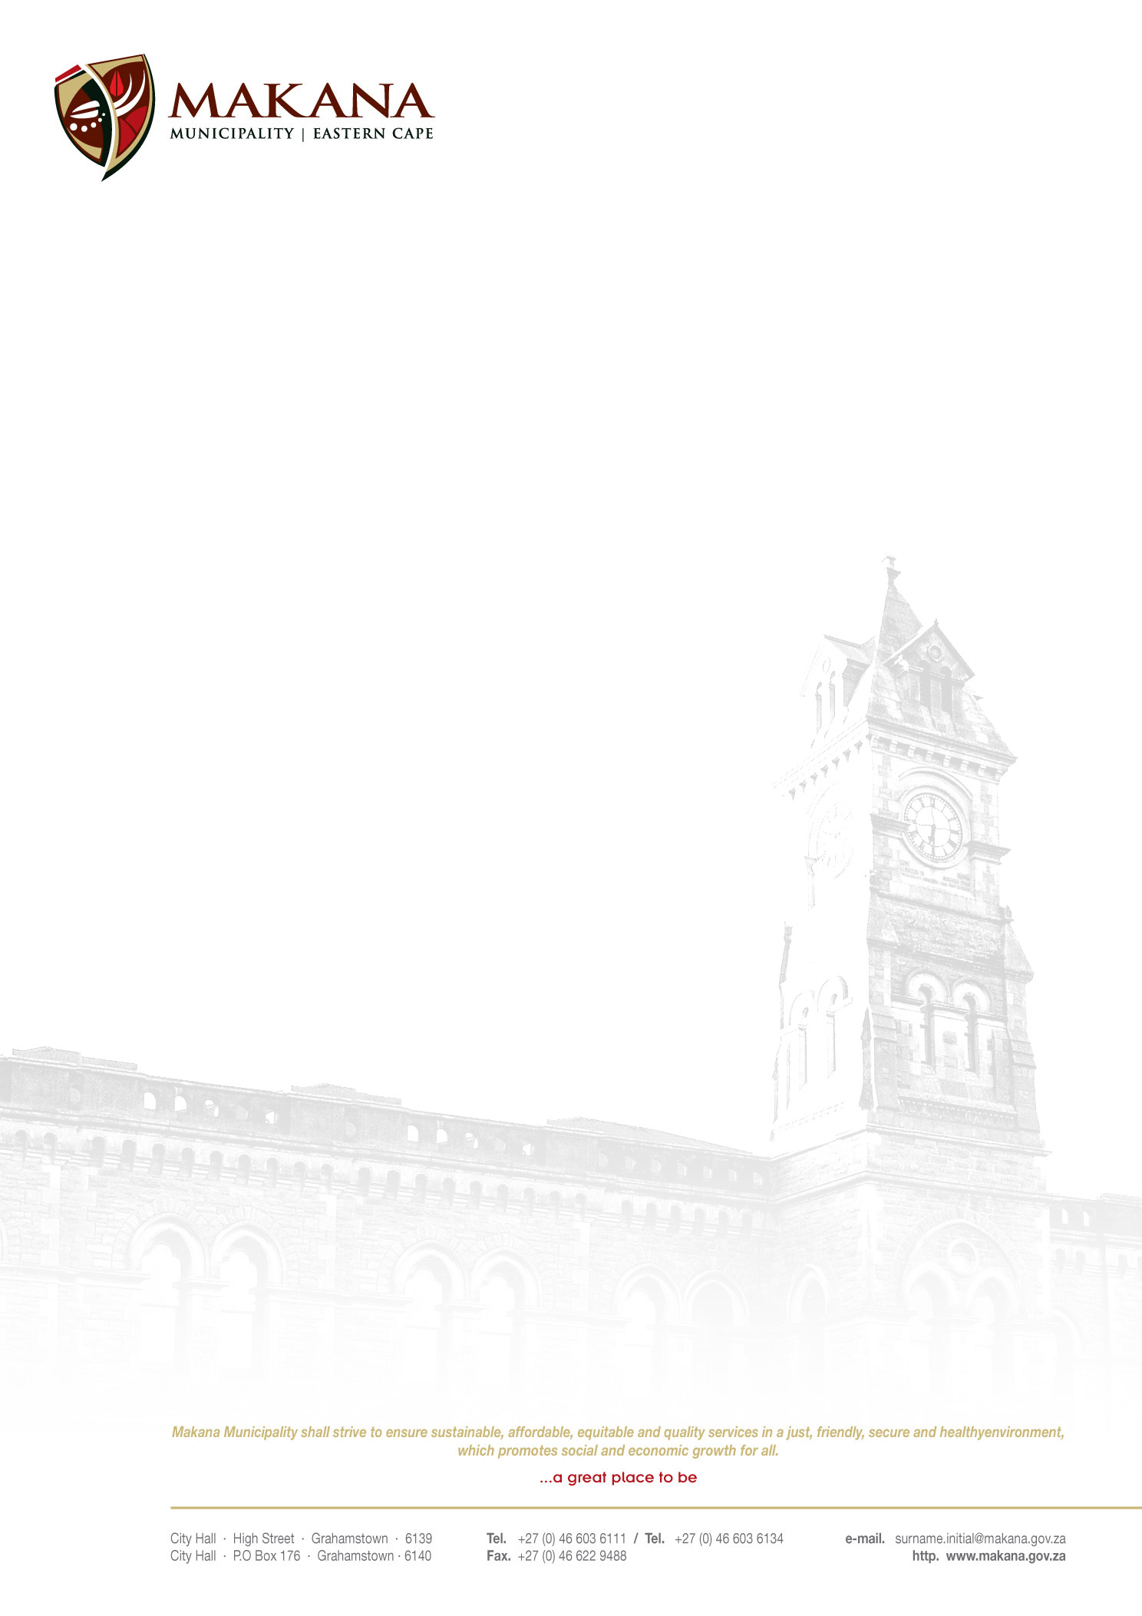

MAKANA MUNICIPALITY

REQUEST FOR QUOTATIONS
RFQ NO: 15 / 2016

APPOINTMENT OF A SUITABLE QUALIFIED SERVICE PROVIDER FOR THE HIRING OF EXCAVATOR

Makana Municipality seeks to secure services of an experienced and competent service provider for hiring of an excavator.

Specification:

- Digging of gravel and stock piling at the Gravel Quarry
- Wet – provide own diesel
- Own operator
- ± 500 cubes

Selection Process and Criteria

- Clear track record with proven competency in the field
- Availability of Machinery and Equipment designed to execute the job

Duration of the Project

- Contractors must complete the work within a period of 3 weeks.

The service provider:
- Undertakes to act as an independent contractor in respect of the work.
- Shall exercise all reasonable skill, care and diligence in the execution of the work and shall carry out all its obligations in accordance with professional standards.
- Shall not have the power or authority to enter into any contracts or otherwise to bind or incur any liability on behalf of the Makana Municipality

Requirements

- Suppliers must be registered on the Municipal Database (Please state your supplier number as proof of registration)
- Price must be VAT inclusive and fixed (for all registered vendors)
- A supplier must quote on all items. If a supplier does not quote on all the items they will be disqualified.
- The Municipality is not obliged to accept the lowest or any quotation;
- A firm delivery period must be indicated
- All quotations will adjudicated in terms of Council’s Supply Chain Management Policy
- The following documentation must be submitted with your quote in order to be considered, failing which will lead to disqualification;
- An original valid SARS Tax Clearance Certificate
- A valid Billing Clearance Certificate from your Local Municipality
- Copy/ies of the Company registration .e.g. CK1, CK2, Trust documents, sole provider ect.
- Original certified copies of Directors Identity Documents
- An original certified copy of the B-BBEE certificate
- Completed MBD 4 form (Declaration of interest)
- Completed MBD 9 form (Certificate of Independent Bid Determination)

- Please ensure that all returnable documentation are numbered (e.g. page 1 of 5 ect) and binded in 1 (one) document;
- The quotations must be submitted on the Letterhead of your business.
- Please ensure that the returnable documentation is placed ina sealed envelope clearly indicating the RFQ NUMBER & DESCRIPTION on the envelope.
- The quotation box is located upstairs situated in the Finance Directorate, 86 High Street, Grahamstown (During normal office hours).
- Quotations that are late will not be accepted
- Quotations per fax or e-mail will also not be considered
- The evaluation criteria is 80/20

NB: BIDDERS WHO ARE IN THE SERVICE OF THE STATE WILL NOT BE CONSIDERED
Quotations must be hand delivered to the Finance Directorate.

For further inquiries contact Mr. K. Mbangi at 046 – 603 6092 or email kwanele@makana.gov.za

Closing date: 18 May 2016 at 12H00

MS MJ MEIRING
ACTING MUNICIPAL MANAGER

