MAKANA MUNICIPALITY

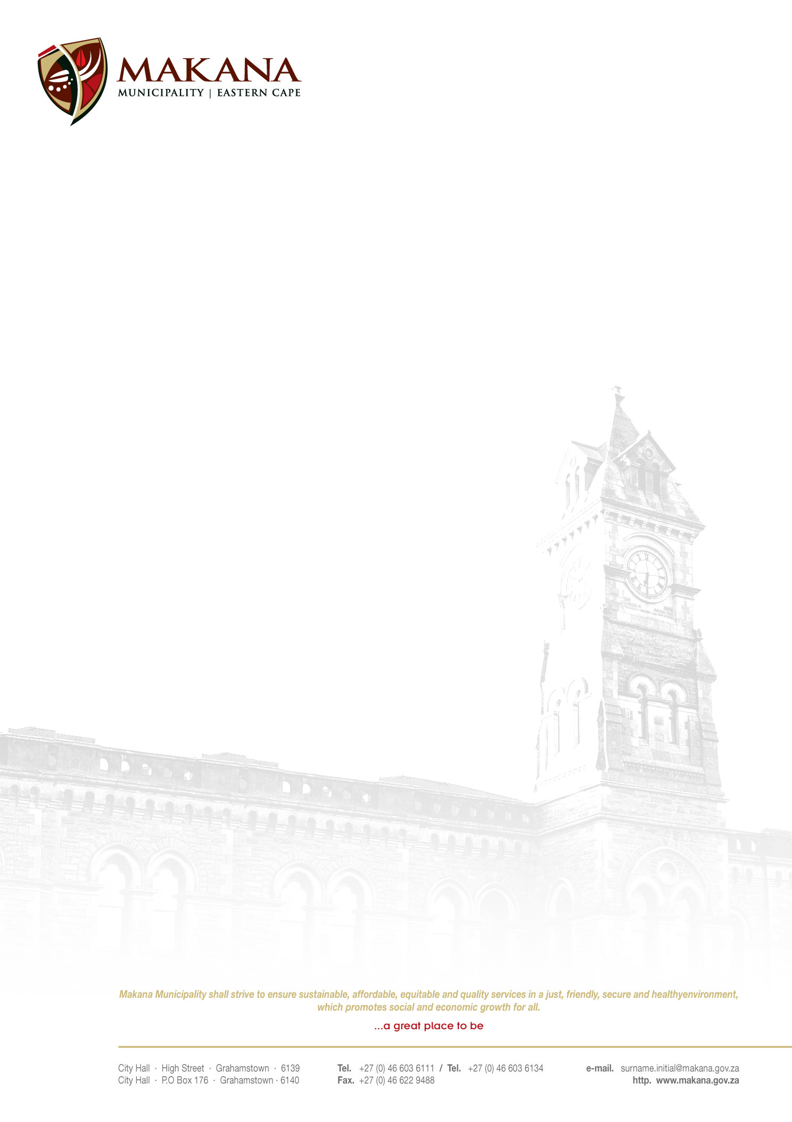
REQUEST FOR QUOTATIONS
QUOTATION NO: 62/2015

SERVICE, RECHARGE, REPAIR OF MUNICIPAL FIRE EQUIPMENT AND SUPPLY NEW FIRE EQUIPMENT WHERE REQUIRED.

Quotations are hereby invited from experienced and suitable service providers to Service, Recharge, Repair, Hydrostatic Pressure Testing of Municipal Fire Equipment and also supply new Fire Equipment where required. Service Providers must be registered with relevant institutions such as SAQCC, FFETA, SABS, SAMSA etc. All work to be carried out as per SANS 1475 Code of Practice by suitably qualified technicians. Liability insurance cover to be carried by the Service Provider for work carried out.

ITEM | PRICE
Service cost per DCP Fire Extinguisher
Service cost per CO2 Fire Extinguisher
Service cost per Hose Reel
Cost of New 4,5 Kg DCP Fire Extinguisher
Cost of New 5 Kg CO2 Fire Extinguisher
Cost of New 2 Kg CO2 Fire Extinguisher
Recharging cost per DCP Fire Extinguisher
Recharging cost per CO2 Fire Extinguisher
Nitrogen refilling cost per Fire Extinguisher
Cost per Photo Luminated signage SABS Approved 190 x 190
Cost per plain SABS approved signage 290 x 290

The costs will be calculated for +- 250 Fire Extinguishers and +- 20 Fire Hose Reels.

NB: A report of all work carried out must be submitted to the Manager: Fire Services by the Service Provider.

The following conditions will apply:
- Suppliers must be registered on the Municipal Database (Please state your supplier number as proof of registration)
- Price must be VAT inclusive and fixed (for all registered vendors)
- The Municipality is not obliged to accept the lowest or any quotation;
- A firm delivery period must be indicated
- All quotations will adjudicated in terms of Council’s Supply Chain Management Policy
- The following documentation must be submitted with your quote in order to be c considered, failing which will lead to disqualification;
- An original valid SARS Tax Clearance Certificate
(UNLESS the bidder is registered on the Accredited Supplier Database of the municipality and the municipality has a valid original Tax clearance certificate on record. The onus is on the service provider / bidder to ensure that the municipality has a valid original Tax Clearance certificate on record (prior to submission of their quotation).
- A valid Billing Clearance Certificate from your Local Municipality or lease agreement
- Coy/ies of the Company registration .e.g. CK1, CK2, Trust documents, sole provider ect.
- Original certified copies of Directors Identity Documents
- An original certified copy of the B-BBEE certificate
- Completed MBD 4 form (Declaration of interest)
- Completed MBD 9 form (Certificate of Independent Bid Determination)
- Proof of registration with relevant institutions such as SAQCC, FETA, SABS, SAMSA ect. Must be submitted. If not submitted this will result in disqualification.
- This request for quotation must be valid for a one (1) year from date of appointment.

- Please ensure that all returnable documentation are numbered (e.g. page 1 of 5 ect) and binded in 1 (one) document;
- The quotations must be submitted on the Letterhead of your business.
- Please ensure that the returnable documentation is placed in a sealed envelope clearly indicating the RFQ NUMBER & DESCRIPTION on the envelope.
- The quotation box is located upstairs situated in the Finance Directorate, 86 High Street, Grahamstown (During normal office hours).
- Quotations that are late will not be accepted
- Quotations per fax or e-mail will also not be considered
- The evaluation criteria is 80/20

NB: BIDDERS WHO ARE IN THE SERVICE OF THE STATE WILL NOT BE CONSIDERED

For further inquiries contact Mr. W. Welkom on 046 – 6036000 or email to Welkom@makana.gov.za
Closing date: 1 December 2015 at 12H00

_____________________
MS. M.J.MEIRING
ACTING MUNICIPAL MANAGER

