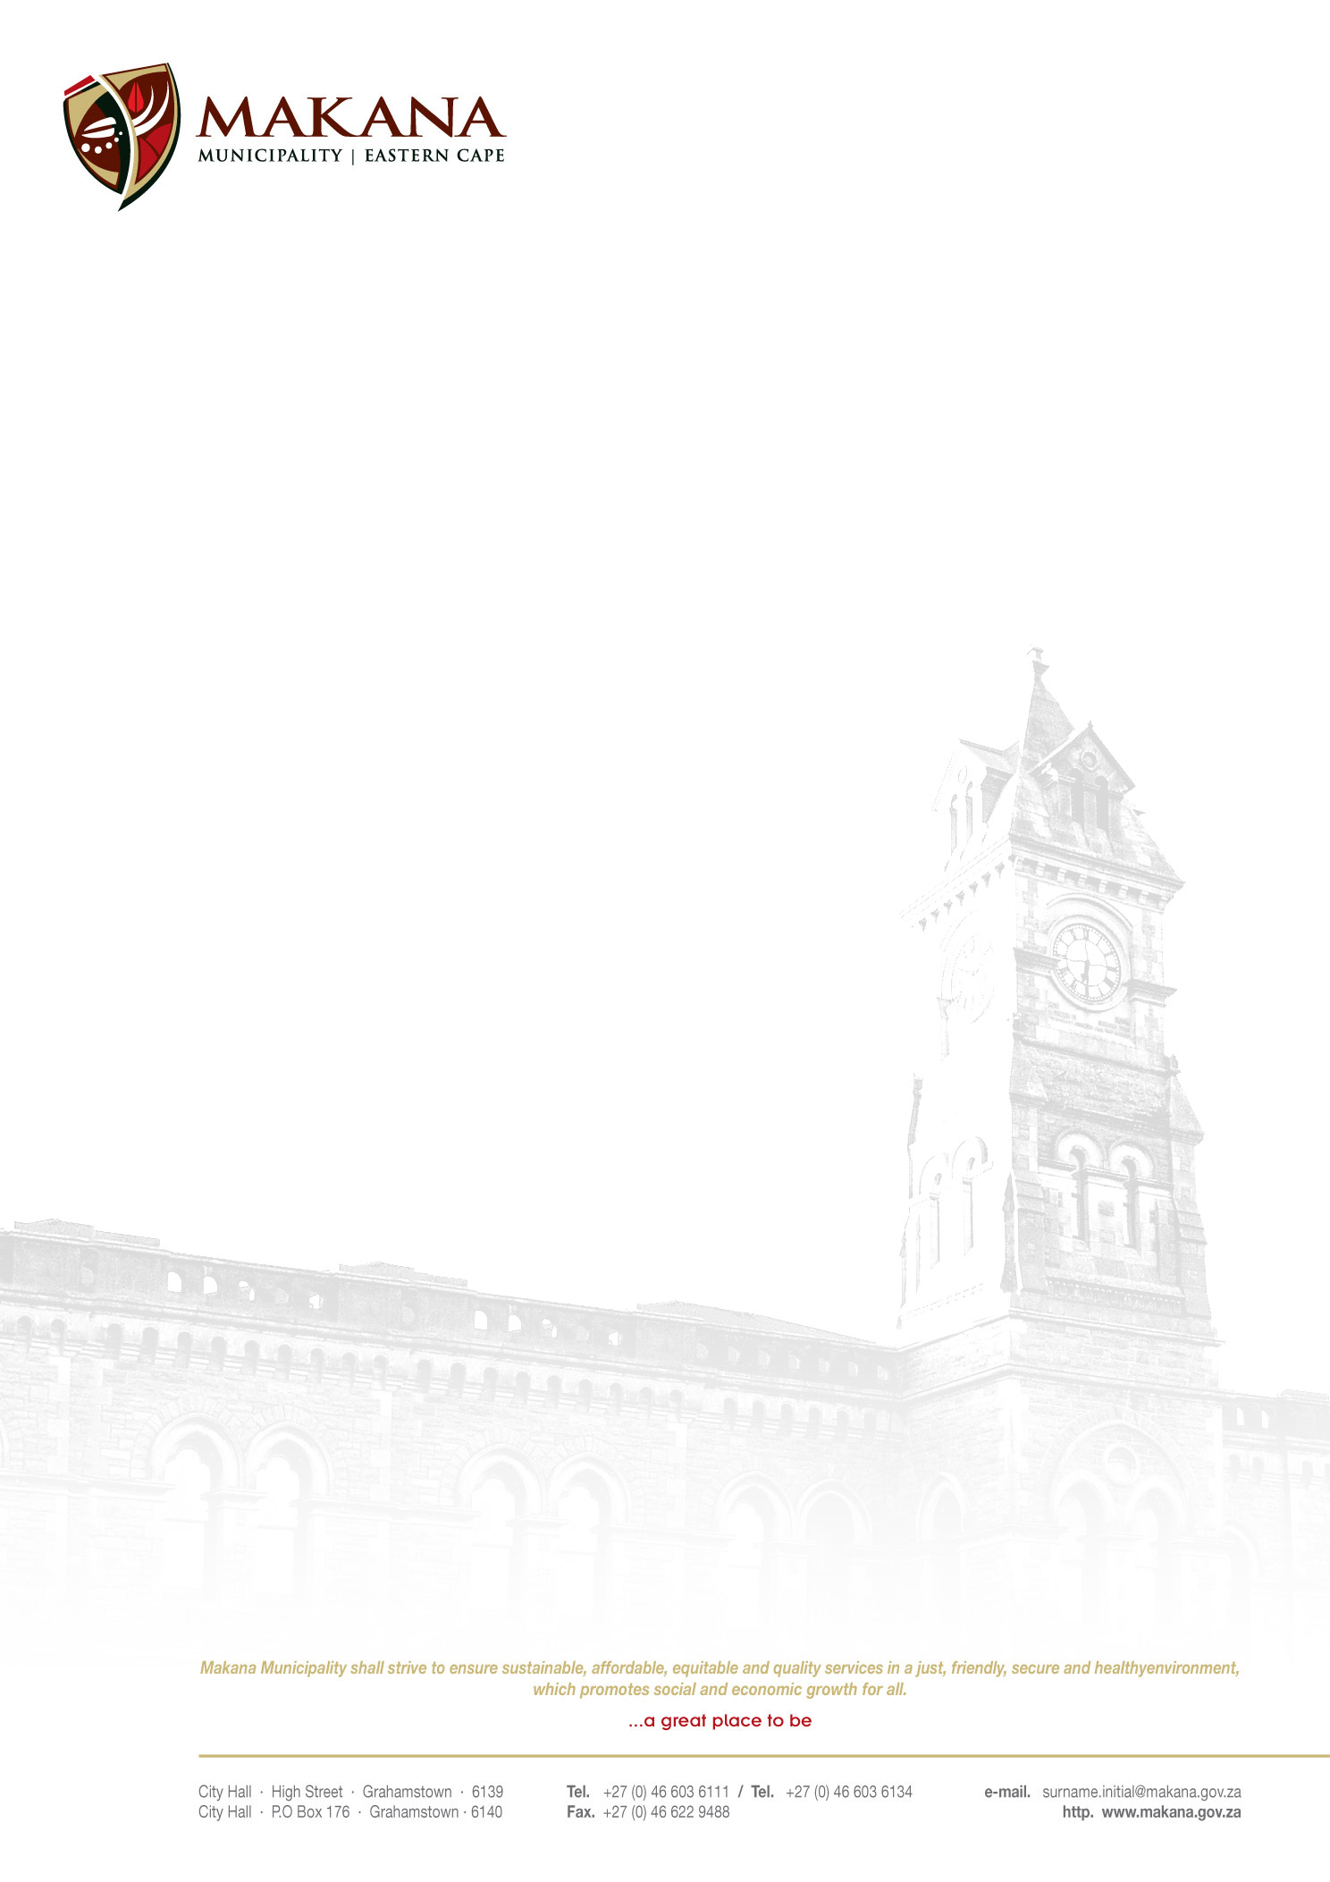

MUNICIPALITY

REQUEST FOR QUOTATIONS
RFQ NO: 57 / 2015

CONSTRUCTION OF PLINTHS AND ARENA AT THE EGAZINI HERITAGE SITE

Quotations are hereby invited from experienced and suitable service providers to supply and delivery as per the specification:-

ITEM | QUANTITY
- Excavation of plinths to be built with bricks, plastered and reinforced with iron rods  - Where necessary placing of 100 mm layer of G5 material under the bases compacted to 95 % density  - Complete the arena concrete circle using appropriate material  - Placing of 100 mm layer of G 5 material under the arena compacted to 95 % density | Twelve (12)
Contract Duration:  Contract duration will be 6 weeks following the conclusion of a service contract.  Retention:  10% retention on completion and handover. Retention period will be 90days  Note: Provision of an action plan together with an architectural illustration of what is to be delivered is essential. | Twelve (12)

- Suppliers must be registered on the Municipal Database (Please state your supplier number as proof of registration)
- Price must be VAT inclusive and fixed (for all registered vendors)
- The Municipality is not obliged to accept the lowest or any quotation;
- A firm delivery period must be indicated
- All quotations will adjudicated in terms of Council’s Supply Chain Management Policy
- The following documentation must be submitted with your quote in order to be considered, failing which will lead to disqualification;
- An original valid SARS Tax Clearance Certificate
(UNLESS the bidder is registered on the Accredited Supplier Database of the municipality and the municipality has a valid original Tax clearance certificate on record. The onus is on the service provider / bidder to ensure that the municipality has a valid original Tax Clearance certificate on record (prior to submission of their quotation).
- A valid Billing Clearance Certificate from your Local Municipality/ Affidavit must be accompanied with a valid lease agreement.
- Copy/ies of the Company registration .e.g. CK1, CK2, Trust documents, sole provider ect.
- Original certified copies of Directors Identity Documents
- Ann original certified copy of the B-BBEE certificate
- Completed MBD 4 form (Declaration of interest)
- Completed MBD 9 form (Certificate of Independent Bid Determination)
- A list of similar projects that your company has undertaken previously, including references.
- CV’s for all people that are going to be involved in this project

- Please ensure that all returnable documentation are numbered (e.g. page 1 of 5 ect) and binded in 1 (one) document;
- The quotations must be submitted on the Letterhead of your business.
- Please ensure that the returnable documentation is placed ina sealed envelope clearly indicating the RFQ NUMBER & DESCRIPTION on the envelope.
- The quotation box is located upstairs situated in the Finance Directorate, 86 High Street, Grahamstown (During normal office hours).
- Quotations that are late will not be accepted
- Quotations per fax or e-mail will also not be considered
- The evaluation criteria is 80/20

NB: BIDDERS WHO ARE IN THE SERVICE OF THE STATE WILL NOT BE CONSIDERED

Quotations must be hand delivered to the Finance Directorate.

For further inquiries contact Mr T. Sindani on 046 – 6036124 (Office Hours)

Closing date: 29 July at 12H00

MS. M. J. MEIRING
ACTING MUNICIPAL MANAGER

