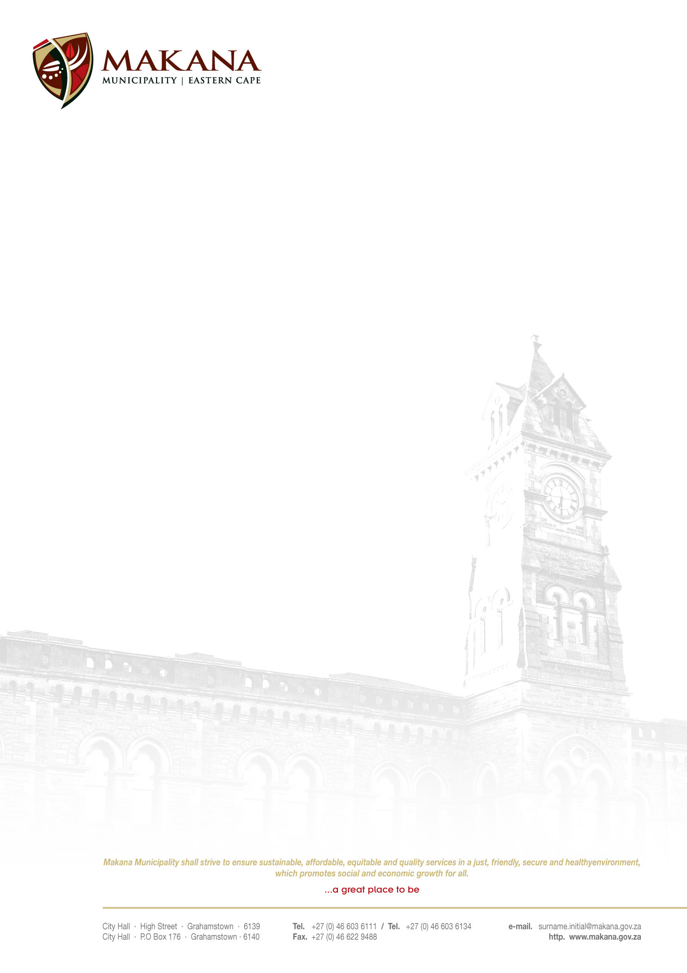

MAKANA MUNICIPALITY

REQUEST FOR QUOTATIONS
RFQ NO: 44/ 2015

PROVISION OF BUSH-CLEARING, ALIEN ERADICATION, MOWING AND GENERAL GROUND CLEAN-UP OF MAKANA CEMETRIES

Quotations are hereby invited from experienced and competent service providers to bush-clearing, alien eradication, mowing and general ground clean-up of Kwa-Tata Cemetery and Waainek:

- The outputs expected are as follows:
All the lawns shall be neatly trimmed and maintained to a height not greater than 25mm.
All the edges are to be neatly trimmed to the same standard as the grassed areas. Care must be taken not to cause damage to the stems of trees and shrubs when trimming edges. Trimming and mowing shall be undertaken simultaneously or with within 10 days of the contact commencing

The contractor shall collect and remove all litter and foreign objects from the site, prior to mowing and dispose of it at the municipal refuse site. Sites with excessive rubbish must be reported to the appropriate Section Head prior to cutting for alternate arrangements.
The contractor shall remove all grass cuttings from the site within the 10 days window period allowed for completing the contract
Work shall commence within 7 working days on the receipt of an official municipal order OR written approval from the Assistant Director: Parks and Recreation Department or his representative.

2. Selection Process & Criteria
- Clear track record with proven competency in the field
- Submission of recommendation letter for work done not older than 3 months.
- Company Health and Safety Measures/ Health and Safety File
- Workmen Compensation Certificate/Letter of good standing from Department of Labour
- Availability of Machinery and Equipment designed to execute the job

NB: All equipment will be inspected immediately after the brief in the site meeting; contractors are invited to observe the inspection. If not inspected on the day the site meeting your quote will be deemed as non-responsive.
Scoring System

Functionality will be scored as follows:

- Required documents: Workmen Compensation; Health and Safety; Recommendation Letter – 15 points
- Machinery & Equipment – 85 points
5 Weed Eaters – 20 points
5 Lawn Mowers 20 points
Brush-cutters with 3 point blades - 30 points
Truck/Bakkie – 15 points

Quotations are to be placed in two separate envelopes sealed envelopes one for Functionality and the other for Price. Envelopes for functionality will be opened and evaluated first and those bidders' price envelopes who fail to acquire the minimum 60% qualifying mark on functionality will not be evaluated for price.

- Suppliers must be registered on the Municipal Database (Please state your supplier number as proof of registration)
- Price must be VAT inclusive and fixed (for all registered vendors)
- The Municipality is not obliged to accept the lowest or any quotation;
- A firm delivery period must be indicated
- All quotations will adjudicated in terms of Council’s Supply Chain Management Policy
- The following documentation must be submitted with your quote in order to be considered, failing which will lead to disqualification;
- An original valid SARS Tax Clearance Certificate
(UNLESS the bidder is registered on the Accredited Supplier Database of the municipality and the municipality has a valid original Tax clearance certificate on record. The onus is on the service provider / bidder to ensure that the municipality has a valid original Tax Clearance certificate on record (prior to submission of their quotation).
- A valid Billing Clearance Certificate from your Local Municipality
- Copy/ies of the Company registration .e.g. CK1, CK2, Trust documents, sole provider ect.
- Original certified copies of Directors Identity Documents
- Ann original certified copy of the B-BBEE certificate
- Completed MBD 4 form (Declaration of interest)
- Completed MBD 9 form (Certificate of Independent Bid Determination)

- Please ensure that all returnable documentation are numbered (e.g. page 1 of 5 ect) and binded in 1 (one) document;
- The quotations must be submitted on the Letterhead of your business.
- Please ensure that the returnable documentation is placed ina sealed envelope clearly indicating the RFQ NUMBER & DESCRIPTION on the envelope.
- The quotation box is located upstairs situated in the Finance Directorate, 86 High Street, Grahamstown (During normal office hours).
- Quotations that are late will not be accepted
- Quotations per fax or e-mail will also not be considered
- The evaluation criteria is 80/20

NB: BIDDERS WHO ARE IN THE SERVICE OF THE STATE WILL NOT BE CONSIDERED

Quotations must be hand delivered to the Finance Directorate.

For further inquiries contact Mr K Mbangi on 046 – 6036093 (Office Hours) or email: KwaneleMbangi@makana.gov.za

Closing date: 2 June 2015 at 12H00 | Compulsory site meeting  Thursday 28th May 2015 @ 9h00  Venue: Parks Department

MR M. PLANGA
ACTING MUNICIPAL MANAGER

