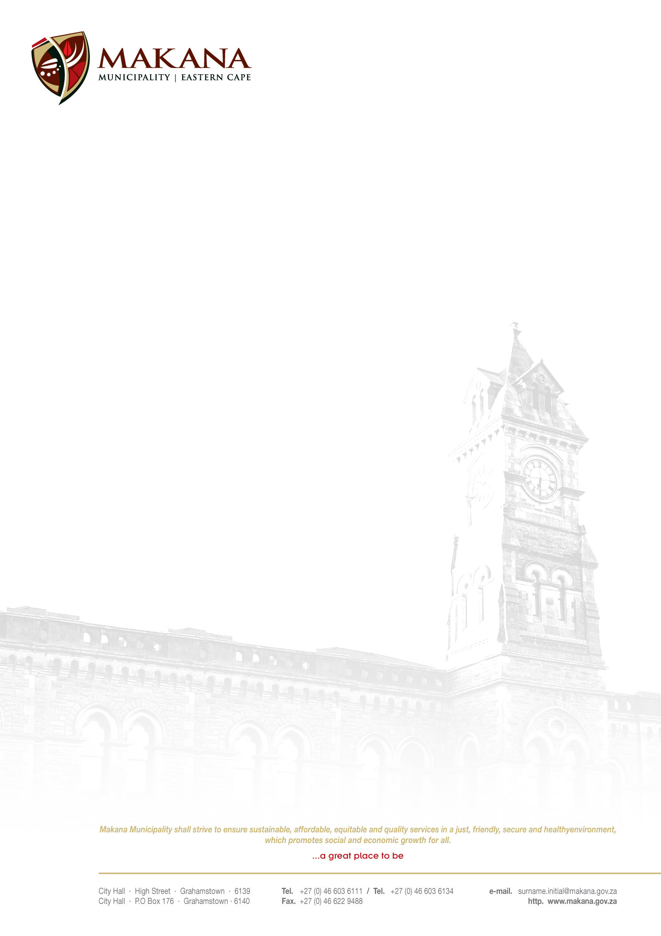

MAKANA MUNICIPALITY

REQUEST FOR QUOTATIONS
RFQ NO: 40/ 2015

SUPPLY AND DELIVERY OF OFFICE FURNITURE

Quotations are hereby invited from experienced and suitable service providers to supply and delivery of OFFICE FURNITURE with the following specifications

ITEM | QUANTITY
Office desk (1800 x 750) with fitted 3 drawer pedestal and 1 standard and 1 x deep filer pedestal both with top locks | One (1)
Computer workstation (1600 x 1200) with desk height pedestal  Two drawer open filer with top lock and fitted drawer pedestal with top lock | Three (3)
Sliding door credenza with shelve and lock | Two (2)
Four drawer Filing cabinets with central locking | Four (4)
System cabinet with shelves and lockable hinged doors | Four (4)
Black polyurethane visitor’s chairs with steel frame and polyprop arms. No Mechanisms | Five (5)
Black polyurethane high back chairs with polyprop arms and nylon base. Gas height adjustment, swivel and tilt mechanism | Two (2)
Five tier bookcase (800mm (L) x 420mm (W) x 2010mm (H) | Two (2)

THE FURNITURE MUST BE WOODEN (NATURAL CHERRY FINISH)

- Suppliers must be registered on the Municipal Database (Please state your supplier number as proof of registration)
- Price must be VAT inclusive and fixed (for all registered vendors)
- The Municipality is not obliged to accept the lowest or any quotation;
- A firm delivery period must be indicated
- All quotations will adjudicated in terms of Council’s Supply Chain Management Policy
- The following documentation must be submitted with your quote in order to be considered, failing which will lead to disqualification;
- An original valid SARS Tax Clearance Certificate
(UNLESS the bidder is registered on the Accredited Supplier Database of the municipality and the municipality has a valid original Tax clearance certificate on record. The onus is on the service provider / bidder to ensure that the municipality has a valid original Tax Clearance certificate on record (prior to submission of their quotation).
- A valid Billing Clearance Certificate from your Local Municipality
- Copies of the Company registration .e.g. CK1, CK2, Trust documents, sole provider etc.
- Original certified copies of Directors Identity Documents
- Ann original certified copy of the B-BBEE certificate
- Completed MBD 4 form (Declaration of interest)
- Completed MBD 9 form (Certificate of Independent Bid Determination)

- Please ensure that all returnable documentation are numbered (e.g. page 1 of 5 ect) and binded in 1 (one) document;
- The quotations must be submitted on the Letterhead of your business.
- Please ensure that the returnable documentation is placed ina sealed envelope clearly indicating the RFQ NUMBER & DESCRIPTION on the envelope.
- The quotation box is located upstairs situated in the Finance Directorate, 86 High Street, Grahamstown (During normal office hours).
- Quotations that are late will not be accepted
- Quotations per fax or e-mail will also not be considered
- The evaluation criteria is 80/20

NB: BIDDERS WHO ARE IN THE SERVICE OF THE STATE WILL NOT BE CONSIDERED

Quotations must be hand delivered to the Finance Directorate.

For further inquiries contact Ms Spondo on 046 – 6036040 (Office Hours)

Closing date: 25 May 2015 at 12H00

MR M. PLANGA
ACTING MUNICIPAL MANAGER

