**TO THE RESIDENTS**

**SUBJECT**

**UPDATE ON IMPROVEMENTS AND THE STATE OF INFRASTRUCTURE IN MAKANA LOCAL MUNICIPALITY.**

**DATE**

**January 28, 2020**

1. **PURPOSE**
   1. To appraise the residents with regards to improvements to the state of water and sewer infrastructure and basic service delivery in Makana Local Municipality.
   2. The information contained herein is based on the information derived from MISA and COGTA involvement in the Makana Local Municipality on the Infrastructure/technical support programme, and information supplied by the District Support Team (DST).
2. **BACKGROUND**

The Makana Local Municipality forms part of the Sarah Baartman District Municipality in the Eastern Cape Province. It is the local municipality which governs the town of (Makana) as well as the towns and villages of Alicedale, Seven Fountains, Riebeeck East and Fort Brown.

The Municipality has been experiencing lack of basic service provision for several years, and persistent drought conditions aggravated this lack of basic service provision.

The drought is by far the worst drought in history, resulting in very low dam levels which have led to the town experiencing a water crisis. The recent rains have done very little to alleviate the challenge.

The problem was escalating at a very high pace which led the Municipal Manager (MM), Mr M Mene to convene a meeting held in the Council Chambers on 14 January 2019, the meeting was attended by several stakeholders representing the residents of Makana and representatives of government sector departments, it was agreed that a Water Crisis Disaster Management Plan needs to be compiled to identify interventions to mitigate the water crisis. A Water Crisis Joint Operations Committee (WCJOC) was established to develop and implement the Disaster Management Plan.

The WCJOC was made up of the following Stakeholders:

* Makana Municipality
* Municipal Manager (Committee Chair)
* Chief Financial Officer
* Local Economic Development Director
* Communications
* Technical Services
* District and Provincial Disaster Management
* CoGTA Provincial & National
* MISA
* MBB Consulting Engineers (EC) (MBB)
* Rhodes University
* National Arts Festival (NAF)
* 6SAI Military Base

The inclusion of the following departments: reinforced the Committee

* Office of the Premier (OTP)
* Department of Water & Sanitation (Provincial & National)
* Presidential Infrastructure Coordination Commission
* Amatola Water Board

Further to the above, the committee could invite ad hoc stakeholder representation as required for the implementation of the Disaster Management Plan.

The WCJOC described above was a decision making and planning entity whose primary goal is to limit and contain the impact of the current disaster situation on the community. The committee still meets every week in Makana to access and update the response to the water crisis and basic infrastructure provision.

1. **PHYSICAL ACHIEVEMENTS ON WATER INFRASTRUCTURE**

Water Crisis Disaster Management Plan included the following work:

* + Water loss management through leak repairs, zone and domestic meter installation for the realisation of revenue enhancement,
  + Repair or replacement and upgrading or expansion of telemetry system at reservoirs.
  + Upgrading of SCADA
  + Refurbishment and or replacement of pump sets and equipment (i.e. pumps, motors, electricity supply, inlet screen, valves, etc.) at pump stations.
  + Cleaned, refurbished and secured two reservoirs.
  + Facilitated and managed the transfer of water to mitigate the water crisis.
  + Attended to emergency/crisis interventions that affected water supply.
  + Facilitated and managed the transfer of water to mitigate the water crisis.
  + Attended to emergency/crisis interventions that affected water supply.

|  |  |
| --- | --- |
| **AREAS** | **ACHIEVEMENTS** |
| **Makhanda**:    **Water shortage and Water loss management** | The work done included the repair of known leaks on bulk lines and occasional bursts that occurred, as well as major leaks reported on Mobisam to minimise losses.  Old Fire Hydrants were replaced, domestic leaks & faulty valves were fixed and broken/ missing water meters were replaced on a day to day basis by at least one of the teams.  This resulted in **459 leaks** being repaired, saving an estimated **118,972 litres** of water savings.  ***The occurrence of leaks is, however, still an ongoing problem and needs a lot more future attention as the existing infrastructure has, for the most part, exceeded its maximum life expectancy*.** |

|  |  |
| --- | --- |
| **Revenue Enhancement and**  **Zone Metering**                  **Telemetry: Reservoirs**        **Upgrading of SCADA.** | 8 new bulk mechanical water meters with loggers were purchased to replace vandalised ones, in order to facilitate the monitoring of consumption and compare day/night flow rates. Makana  The other existing electromagnetic water meters were fitted with either new batteries for their loggers or had new loggers fitted.  All of the bulk meters were provided with a new 24month GSM contract and can, therefore, report to the “My City” Website daily and SCADA for monitoring.    The Secondary reservoirs at Botha’s Hill and Intermediate Level were fitted new telemetry and damaged/ vandalised items at Tantyi, and Botha’s Hill reservoirs were repaired and replaced.    The Makana SCADA was upgraded and expanded to the extent that all Major components of the water supply system can now be monitored 24/7 by relevant parties, from anywhere using a Smartphone. i.e. Reservoir levels (excluding Seven Fountains), Pump station telemetry, Water treatment works functions, Bulk water meters and even Boreholes (excluding Seven Fountains) etc. are all now accessible on the SCADA platform.    This greatly enhances the ability to Manage the Makana water system and react to breakdowns or crisis situations and improves overall efficiency, especially during the drought period, where water has to be transferred between the Eastern and Western supply streams and major breaks can lead to unaffordable losses. |

|  |  |
| --- | --- |
| **Refurbishment of Pump stations.**                **Reservoirs cleaning and**  **security**              **Manage Water transfer to alleviate water shortages on the Western side of town.** | **James Kleynhans Pump Station**:    A new motor from ACTOM (motor no. 4) was procured, and the pump (Pump No.4) was refurbished whose impellor was damaged.    Also, pump No.3 is currently being refurbished      Intermediate reservoir No. 1 and Old Bothas Hill reservoirs were cleaned. ***( A tender is out for the fencing of Botha’s Hill reservoir)***  Only the Intermediate No. 1 & 2 reservoirs have been secured with electric fencing.  Vandal-proof manhole covers were fitted to the seven most often vandalised water meter and control valve chambers, and an 8th one purchased for the outlet at Bothas Hill bulk water meter chamber that has to be built.    Water is currently balanced to serve all of Makhanda community.  This is largely possible due to the increased production achieved at James Kleynhans WTW as a result of the work done.    The Reticulation system has also been set up to be kept as stable as possible to avoid constantly fluctuating pressures, to minimise stresses on old AC infrastructure. |

|  |  |
| --- | --- |
| **Crisis/Emergency**  **Intervention James**  **Kleynhans WTW**                            **Items attended at JK WTW:**    **Chemical Treatment**                  **Clarifiers**                  **Filtration** | Early in 2019, James Kleynhans WTW experienced a sudden and drastic reduction in production from its design capacity of 10 Ml/day to roughly 3-4Ml/day. Upon investigation, it became apparent that serious intervention was required and quick action had to be taken.  All facets of the treatment process had to be attended to.  Raw water chemical treatment had to be adjusted due to higher than normal raw water turbidity and the dosing equipment needed attention.  The clarifiers were completely clogged, and the filtration system was practically non-functional.  JKWTW currently produces between 12-13Ml per day and is therefore now able to supplement the shortage experienced on the Western side of the water supply to town to a large extent.    The chemical treatment facility was brought back to full functionality by repairing broken pipework, repairing the chlorine dosing equipment and the mixing channels were improved by adding more baffles to ensure better chemical distribution. i.e. ”Floc” treatment. A special batch of Flocculent had to be purchased in order to deal with the temporary increase in turbidity due to Glen Melville Dam having been filled up after good rain in the Fish River catchment.  All the clarifier de-sludge valves were found to be non-functional, which led to complete congestion and therefore resulted in the filters getting blocked by having to deal with very turbid water and unabsorbed flocculent. A total of 360m3 of sludge was pumped out of the Clarifiers over a period of 4-5 days. The de-sludge valves were removed, refurbished and reinstated completely with new pneumatics and the blocked Scour lines were cleaned by means of High-Pressure Blasting.  The Clarifiers are now in 100% working order and can be maintained in such a state, with scheduled scouring.  All four filters were found to be blocked, and it was impossible to backwash effectively due to an almost complete breakdown of related equipment. |
| **Filtration (cont)** | Repaired and replaced, where necessary, valves, actuators, pneumatic piping, nozzles, refurbished the compressor, control panels, lights and topped up two of the filter beds with clean sand.  The Filtration Plant is now back to full operation and can even cope with the extra demand due to shortage of water from the Western Side supply. |
| **Refurbishment and upgrading of existing water infrastructure.**  **Drilling and equipping of Boreholes** | A new rising main from Intermediate Reservoir to High-Level Reservoir supply was constructed to enable water from James Kleynhans supply to be pumped to the High-Level reservoir. This included all mechanical, civil and electrical works, and a new pump station with 2 pumps similar to Settlers Dam was commissioned.  A new 160mm diameter uPVC water line was constructed and commissioned to supply Grahamstown Correctional Facility.  A new “Vent-o-mat” air valve was installed on the 300mm bulk line between Grahamstown East and West located near the Intermediate Reservoir to assist with cross transfer of water between supply streams.  Replaced the faulty air valve at the Howieson’s Poort dam Wall and did two major repairs on the Pumping Main to Waainek WTW.  Vandalised level control valves at Mayfield, Tantyi and RU Reservoir, were fixed and are all functioning.  2 new Pump Sets were procured and installed at Settlers Dam pump station.  One Pump for James Kleynhans WTW was refurbished, installed and commissioned.  2 x Pump motors for James Kleynhans WTW and 1 x Pump motor for Howieson’s Poort pump station were refurbished, installed and commissioned.  More than 10 boreholes were drilled in Makana to augment water shortage during the drought period. |

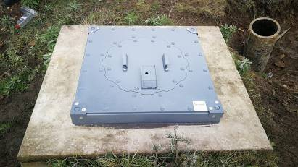

**Photo 1:** New vandal proof manhole covers installed

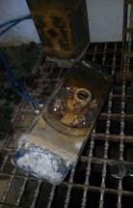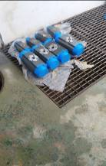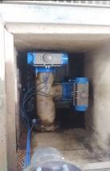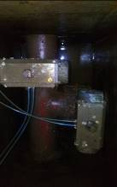

**Photos 2-5:** JK WTW – Faulty actuators replaced with new ones

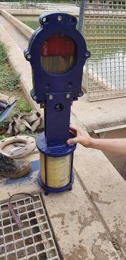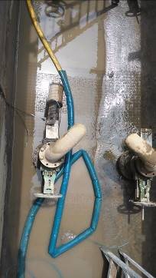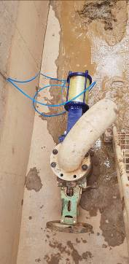

**Photos 6-8:** JK WTW - De-sludging valves refurbished

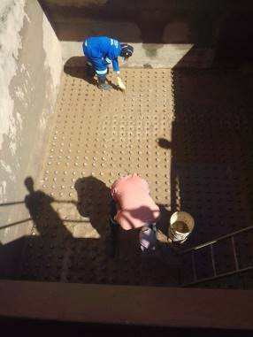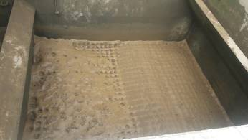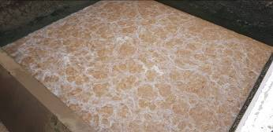

**Photos 9-11:** JK WTW - Filters refurbished

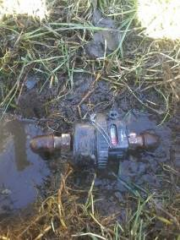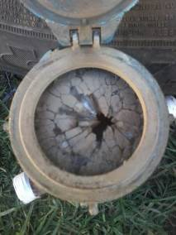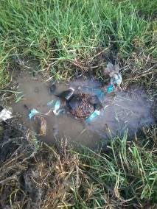

**Photos 12 - 14**: Typical faulty/damaged water meter being replaced with a new one

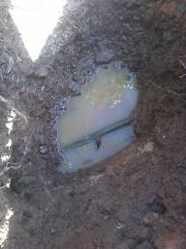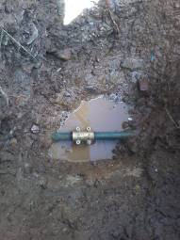

BEFORE AFTER

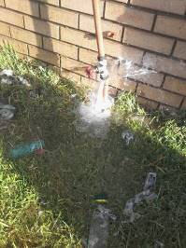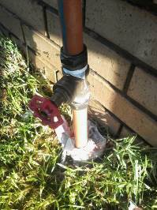

**Photos 15 -18:** Typical leaks being fixed

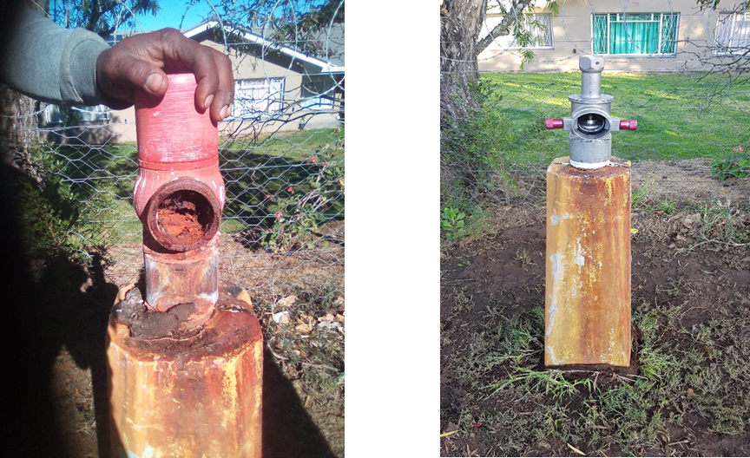

Work was also done in other settlements surrounding Makhanda. The work covered the following areas.

* Fort Brown and
* Seven Fountain

|  |  |
| --- | --- |
| **SEVEN FOUNTAINS**  Seven Fountains WTW | ECDC refurbished the Boreholes in 2018  Due to the increase in population, 20 000l raw water storage capacity was added to the existing 10 000l by means of adding 4 x 5000l Jojo tanks.  All existing pipework was fixed and expanded to accommodate the additional storage tanks, including individual tank isolating valves. In order to prevent UV degradation, the above were protected by wrapping in “Denso” tape. Chemical treatment delivery system leaks were fixed and installed in a protective conduit to prevent future damage. |

|  |  |
| --- | --- |
| Water Reticulation        Elevated storage reservoir. | 5 additional communal standpipes and a fire hydrant were added to the existing water reticulation to accommodate the increase in population and increased demand, and two existing leaking standpipes were fixed.  The Fire Hydrant was positioned to accommodate easy access for a Fire Tender or Fire engine, and a valve spanner was supplied.    Inadequate funding prevented any work to be carried out in this regard.  The 100 000l elevated reservoir, however, can still cope with current demand without having to be filled to the point where it starts leaking. |
| **FORT BROWN.**      Water Treat Works, (WTW)      Rising Main    354 kl concrete  Reservoir        Reticulation | **Refurbishment work and upgrades at the WTW, the 354Kl reservoir and installed an internal distribution system with 5 x communal standpipes and 1 x fire hydrant at the local settlement.**    At the WTW, the external pipework was fixed, and UV damaged pipework was replaced with HDPE pipe and wrapped in “Denso” tape to prevent future damage. Two 10 000l tanks were added to the “Treated” water storage at the plant, doubling capacity. The WTW is now fully operational and back in use.    The Rising Main was inspected and tested, and redundant connections were removed    The unused 354 Kl concrete reservoir was cleaned re-sealed and re commissioned and is currently in use, eliminating the need for Makana to cart water by truck.  A Telemetry system was installed at the reservoir thus enabling Makana Municipality to monitor the level of the reservoir as it is also linked onto the  Makana SCADA.  5 x communal standpipes and 1 x fire hydrant were provided to the community and were placed in positions as agreed with the local leaders. The FH was connected directly to the main supply line and placed in a strategic location. |

**PHOTOS**

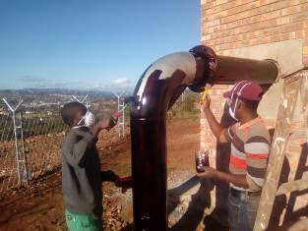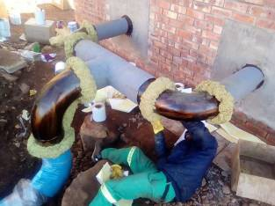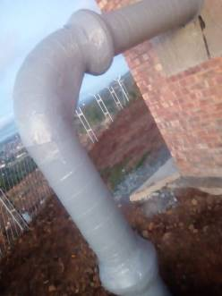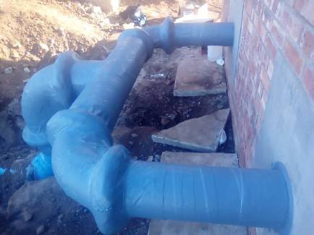

**Photos1-4:** Intermediate Pump Station – Denso tape being applied to all external and underground pipes

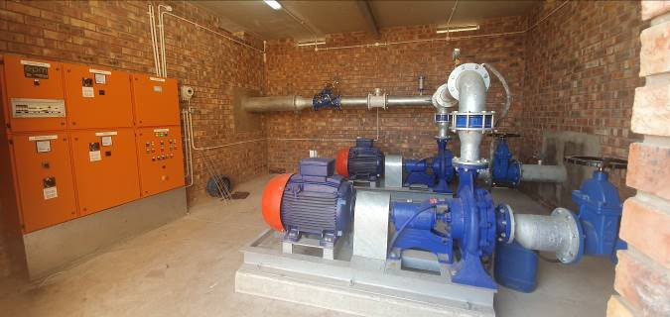

**Photo 5:** Intermediate Pump Station – 2 x pump sets and control panel installed and commissioned.

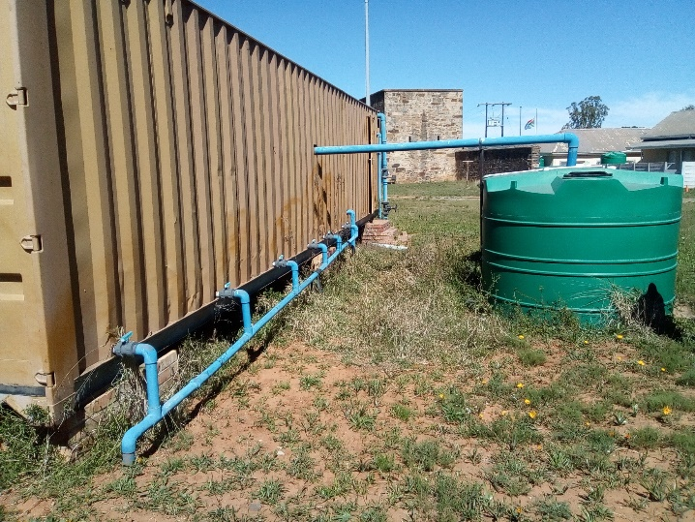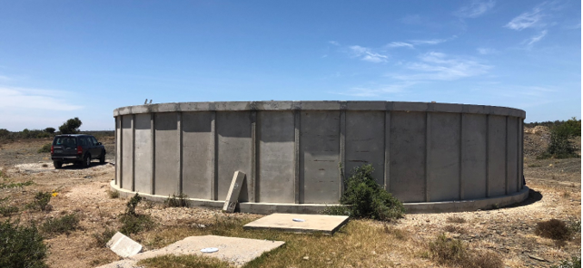

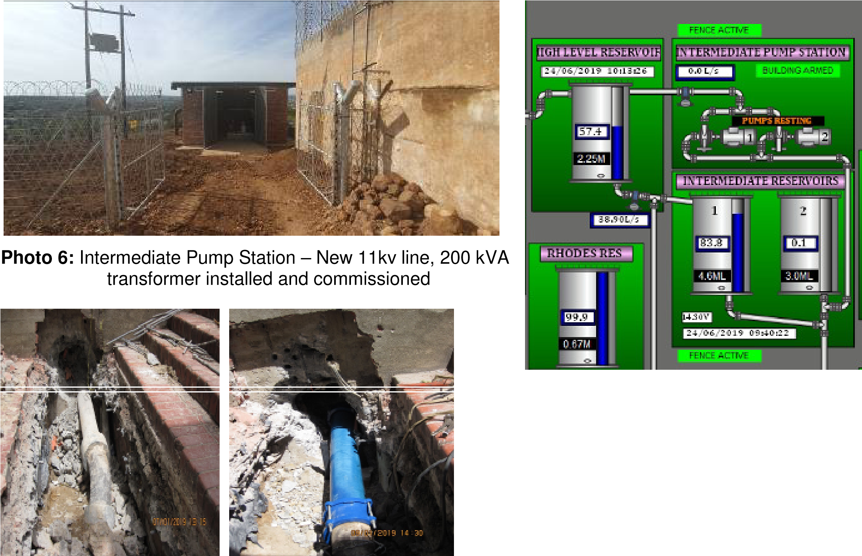 **Photos 7 - 8:** Typical leak fixed

1. **Current water projects being implemented**

|  |  |
| --- | --- |
| **Name of the project** | **Amount** |
| Refurbishment of Riebeek East WTW | 6 955 044 |
| Refurbishment of Jameson and Milner Dam | 10 000 000 |
| Refurbishment of Alicedale WTW | 10 147 495 |
| Purchase James Kleynhans Pump Set | 1 220 000 |
| Fencing of Botha’s Hill Reservoirs | 1 301 739 |
| Feasibility Study of investigation of water supply to Makhanda West from James Kleynhans WTW | 1 421 079 |
| Replacement of Asbestos pipes in water reticulation network in Makhanda | 4 007 617 |
| Waainek Bulk Water Supply Refurbishment (Multi-year Project) | 8 932 226 |
| Groundwater Development (Boreholes) | 8 798 857 |

1. **SEWER INFRASTRUCTURE**

The Makhanda sewer network drains in two distinct drainage areas; namely Mayfield Outfall Sewer in the North and Belmont Valley Outfall in the South.

The northern area drains into Mayfield Waste Water Treatment Works. Sewerage from the northern areas drains via a 2.5km long pipe with the diameter ranging from 250mm to 160mm diameter in some sections. Other branches connect to this line from Extension 6. The northern drainage area includes the following areas: Makanaskop, Mayfield Phase 1, Transit Camp, Kings Flat and Extension 6 & 7. This line blocks on a weekly basis due to new areas being connected to the system, as well as the varying pipe sizes causing bottlenecks. There are also future housing developments planned that would also drain into this line.

The southern drainage area includes the central and western areas of Makhanda, as well as a number of existing residential areas to the east, including Xolani, Tantyi, Lower Makanaskop, Fingo Village and Vukani. There are also future developments planned that would also drain into these lines. This area is served by the Belmont Valley WWTW. The current hydraulic design capacity of this plant is 5.4 Ml/day, but it has been operating at over 8 Ml/day for a couple of years. This is not acceptable as this may result in raw effluent being discharged into a watercourse.

The Belmont Valley WWTW is not only over capacitated, but it is also in a state of disrepair. Investigation of Belmont Valley is not part of the scope.

Sewerage from the southern areas drains via two outfall sewers, a 500mm diameter pipe from De villiers Close and 160mm diameter from Vukani. There is an old-line running parallel to the 500mm diameter outfall which is still in operation. The line from Devilliers Close is blocked at a manhole just below the Fort England Hospital.

Pictures: Typical sewer blockages in Makana

1. **Current Sewer projects being implemented**

|  |  |
| --- | --- |
| **Name of the project** | **Amount** |
| Belmont Valley Wastewater Treatment Works Refurbishment | 5 456 819 |
| Mayfield Gravity sewer | 3 739 130 |
| Refurbishment of Two Sewer Pump Stations in Joza | 3 130 435 |
| Completion of Alicedale Bulk Sewer Pipeline | 3 043 478 |
| Alicedale Sewerage Works | 5 814 181 |

**Urgently required sewer projects that need funding**

|  |  |
| --- | --- |
| **Name of the project** | **Amount** |
| Upgrading of Belmont Valley Wastewater Treatment Works | 149 000 000 |
| Sewer Bulk infrastructure augmentation | 107 000 000 |
| Upgrading of Mayfield Wastewater Treatment Works | 139 000 000 |

* 1. **James Kleynhans Water Treatment Works**

James Kleynhans Water Treatment Works (WTW) is operating on one electrical transformer that was refurbished by MISA. The second electrical transformer, which should provide redundancy, is inoperative and needs to undergo urgent refurbishment.

This puts the WTW in a critical situation if the transformer in use fails. The WTW will not be able to operate and will fail to provide clean drinking water to the town of Makhanda.

7.1 **Roads infrastructure**

The road network of Makana is plagued by potholes and lack of maintenance. From Roads Assessment Management System, the backlog for the upgrade and maintenance of roads entirely in MLM is estimated at R250 Million.

Through the Ministerial intervention, R10m was provided for CBD roads upgrade (the tender is in the process of being re-advertised).

* 1. **Spatial and Development Planning Sector**

The Development Planning Services and Built Environment, in particular, the functions related to the town, spatial & development planning is limited at present. The current capacity includes a Manager: Town Planning (junior professional planner level) with no support staff. There is no senior professional planner.

The current business model and resources relating to this sector does not align with the functions and needs of a modern, growing and active local municipality with developmental challenges. There are legislative requirements that are not being applied. This has resulted in poor strategic planning, with inadequate systems, structures and budgetary constraints hindering effective operations, which is not fully conducive to best practice.

The lack of adequate town & development planning capacity has a negative impact on economic development, job creation, development promotion and overall investment inclusive of stagnant rates and taxes and no new municipal rates and taxes.

A new Spatial Development Framework Plan was developed, funded by MISA/CoGTA, which was completed by 30 September 2019. The SDF includes long-term strategic development planning for Makana, Capital Expenditure Framework, Traffic and Transport management plan for the Makhanda CBD, as well as a development levy policy and calculator.

There is a need for some components of a Land Use Management System, inclusive of a land audit, land management policy and by-law, managed through the municipal GIS. The Municipality has undertaken in-house work on the scheme and land use plans.

The Housing backlog is estimated to be +-10000 units (per 2018 IDP). The Human Settlement Sector Plan is outdated, completed in 2012/13 and needs review.

|  |  |  |  |  |
| --- | --- | --- | --- | --- |
| **MUNICIPALITY** | **PROJECT NAME & DESCRIPTION** | **IDENTIFIED CHALLENGES** | **ACHIEVEMENT TODAY** | **IMPACT** |
| Makana | Rewind and Refurbish Transformers at James Kleynhans Water Treatment Works (JKWTW) | 2 Faulty electrical Transformers that are feeding Electricity to JKWTW | Completed refurbishment of one transformer | JKWTW is feeding water to the whole community of Makhanda. The impact is continuous and stable water supply to Makhanda |
| Makana | Makana Municipal Spatial Development Framework | Lack of planning documents for future infrastructure investment | Makana SDF and Infrastructure investment plan adopted by council in October 2019 | Base planning document for future investment planning, development and implementation of infrastructure projects |

* 1. **Revenue generation**

The annual revenue billed is R 105m and collected is R 94m indicating a 90% collection rate, the shortfall being network electrical losses, indigent basic allocation provisioning, street lights and non-payment. The total Debt book is as follows:

|  |  |
| --- | --- |
| Government Departments | R21million |
| Business | R49.9million |
| Residents | R472million |
| **TOTAL** | **R545million** |

Without the contribution of the above role players in the revenue generation, it will be very difficult for this municipality to deal decisively with the infrastructure backlog.

1. **CONCLUSION**

The drought situation in Makana is efficiently managed by the involvement of other stakeholders and MISA. However, on the other side, the sewer network is dilapidated, and the Sewer Treatment Works are under capacity leading to possibility of raw sewerage being discharged in the rivers.

Gogta/Misa must continue to provide technical support to Makana Local Municipality through the District Support Team. The municipality needs assistance with funding for infrastructure projects that will alleviate our service delivery challenges.

**Makana Municipality Executive Mayor Cllr Mzukisi Mpahlwa.**